

**Session 2017-2021**

**Portage Guide for Early Education: A Digital Assessment Tool**

**Muhammad SaimAkram 17-NTU-1231**

**Hafiz Faisal 17-NTU-1215**

**Areeb Gul 17-NTU-1219**

**Supervised by:**

**Dr. CM Nadeem Faisal**

**CO SUPERVISED BY**

**Dr. Mudassar Ahmad**

**DEPARTMENT OF COMPUTER SCIENCE**

**NATIONAL TEXTILE UNIVERSITY, FAISALABAD**

**DECLARATION**

We hereby declared that this Documentation or Software Requirements Specification (SRS) is completely written by us and it’s our effort and none of anyone from outside of our group has copied it. This Report is purely written technically by our project which is going to be developed. We proudly declared that we haven’t copied any content of this Report from the Internet or any other source.

(Tested on **Turn-it** Software and Found “No Plagiarism Suspected”)

**CERTIFICATION**

This is to certify that this project titled “**Portage Guide for Early Education: A digital Assessment Tool**” was found to satisfy the requirement for the award of “Bachelor of Sciences in Software Engineering” degree by the Department of Computer Science, National Textile University, Faisalabad.

|  |  |  |
| --- | --- | --- |
|  | **Author(s)** |  |
| Group Members:  Muhammad Saim Akram |  |
| 17-NTU-1231  E-Mail: [saimakram41@gmail.com](mailto:saimakram41@gmail.com) | Signature | Date |
| Hafiz Faisal Mukhtar Ahmad |  |  |
| 17-NTU-1215  E-Mail: [faisalmukhtar243@gmail.com](mailto:faisalmukhtar243@gmail.com) | Signature | Date |
| Areeb Gul |  |  |
| 17-NTU-1219  E-Mail: [mareebgull1@gmail.com](mailto:mareebgull1@gmail.com) | Signature | Date |
| Supervisor:  Dr. CM Nadeem Faisal |  |  |
| E-Mail: nadeem.faisal@ntu.edu.pk | Signature | Date |
| Co-Supervisor:  Dr. Mudassar Ahmad |  |  |
| E-Mail: mudassar@ntu.edu.pk | Signature | Date |
| FYP-Convener: Dr. Rehan Ashraf |  |  |
| E-Mail: [rehan@ntu.edu.pk](mailto:rehan@ntu.edu.pk) | Signature | Date |
| Head of Department:  Dr. Muhammad Asif Habib |  |  |
| E-Mail: drasif@ntu.edu.pk | Signature | Date |

##### **Department of Computer Science**

**National Textile University, P.O-37610 Faisalabad**

**ACKNOWLEDGEMENT**

We have taken efforts in this project. A research project like this is never the effort of a single person. The contribution of many people in different ways have made it possible. We would like to express our sincere thanks to all of them.

First and foremost, we would like to thank Allah for giving us the strength, knowledge, and ability to complete this project.

Secondly, we are thankful to Dr. CM Nadeem Faisal andDr. Mudassar Ahmad for their guidance, supervision, and, their support for completing this project. We are also thankful to Dr. Asif Habib for sharing many ideas and providing information regarding this project. We are thankful to all those who directly or indirectly guided us regarding this Project.

We would like to express our special gratitude to other universities and industry persons for giving us time in collecting requirements.

We would like to thank our parents for their unconditional support, both financially and emotionally throughout the degree.

**ABSTRACT**

In the modern world, Intellectual Disabilities in children are a major problem all over the world. Even the developed countries face this problem. When a child's cognitive functioning and abilities, such as communication, self-care, and social skills, are limited, this is referred to as intellectual disability. These limitations in the cognitive functioning of a child can cause slow growth in mental and learning abilities. Intellectual disabilities affect the mental, social, communication, and physical growth of a child. It also affects the problem-solving skills in normal and disabled children. The purpose of this project is to automate the whole learning and assessment process. We will give the proper solution of the difficulties and problems faced by ID assessment Instructors. Our project purpose is to reduce the time consumption of Instructor and children, efforts of the instructors. Our app provide database which will prove helpful in record maintaining issues of child details and assessment results. Instructor can easily maintain the record of the child details and assessment results. Also, our app consists of activities videos that perform by expert staff once.

Table of Contents

**1** **Introduction** 2

**1.1** **What are the Common Causes of Intellectual disability?** 2

**1.2** **Problem Statement** 2

**1.3** **Purpose of the Project** 2

**1.4** **Project Goals** 2

**1.5** **Project Objectives** 2

**1.6** **Project Scope** 2

**1.7** **Product Perspective** 2

**1.8** **Product Functions** 2

**1.9** **PGEE Users** 2

**1.10** **Benefits of PGEE** 2

**2** **Literature Review** 2

**2.1** **Existing System** 2

**2.2** **Proposed system** 2

**2.3** **Reasons for development** 2

**3** **Development Methodology** 2

**3.1** **Project Planning** 2

**3.2** **Methodologies for Software Development** 2

**3.3** **Existing Methodology** 2

**3.3.1** **Agile** 2

**3.3.2** **Waterfall** 2

**3.3.3** **Scrum** 2

**3.3.4** **Extreme Programming** 2

**3.4** **Selected Methodology** 2

**3.5** **Project Scheduling** 2

**3.6** **Feasibility study** 2

**3.6.1** **Technical Feasibility** 2

**3.6.2** **Economical Feasibility** 2

**3.6.3** **Operational Feasibility** 2

**4** **System Requirements** 2

**4.1** **SYSTEM REQUIREMENTS** 2

**4.2** **Functional Requirement** 2

**4.2.1** **Functional Requirements** 2

**4.3** **NON-FUNCTIONAL REQUIREMENTS** 2

**4.3.1** **Usability** 2

**4.3.2** **Accuracy** 2

**4.3.3** **Security** 2

**4.3.4** **Maintainability** 2

**4.3.5** **Compatibility** 2

**4.4** **OVERALL SYSTEM REQUIREMENTS** 2

**4.4.1** **Technical Feasibility Study** 2

**4.4.2** **Economic Feasibility** 2

**4.4.3** **Running Cost** 2

**4.5** **REQUIREMENT ELICITATION** 2

**4.5.1** **Interviews** 2

**4.5.2** **Analysis of Existing System Document’s** 2

**4.5.3** **Observation** 2

**4.6** **USE CASE DIAGRAMS** 2

**4.6.1** **Admin Panel Use Case Scenarios** 2

**4.6.2** **Instructor or Doctor Panel Use Case Scenarios** 2

**4.6.3** **System Use Case** 2

**4.6.4** **Service-Oriented Architecture in Cloud Computing** 2

**5** **System Design** 2

**5.1** **Introduction** 2

**5.2** **Architecture** 2

**5.3** **System Architecture** 2

**5.4** **Sequence Diagrams** 2

**5.4.1** **Login Sequence Diagram** 2

**5.4.2** **View Student List Sequence Diagram** 2

**5.4.3** **Student Details Sequence Diagram** 2

**5.4.4** **Student Test History Sequence Diagram** 2

**5.4.5** **Student Assessment Sequence Diagram** 2

**5.5** **Activity Diagram** 2

**5.5.1** **Admin login Activity Diagram** 2

**5.5.2** **Admin Panel Activity Diagram** 2

**5.5.3** **Instructor Login Activity Diagram** 2

**5.5.4** **Instructor Login Activity Diagram** 2

**5.5.5** **Child Assessment Activity Diagram** 2

**6** **Conclusion and Future Work** **Error! Bookmark not defined.**

**6.1** **Overview** 2

**6.2** **Basic knowledge about React Native framework** 2

**6.2.1** **Why React Native?** 2

**6.2.2** **Frontend structure** 2

**6.2.3** **Structure of the database** 2

**6.2.4** **How to Sign in or Sign Up** 2

**6.2.5** **How sign in works?** 2

**6.2.6** **How does it work?** 2

**6.3** **Backend Structure** 2

**7** **Conclusion and Future Work** 2

**7.1** **Conclusion** 2

**References** 2

**Abbreviations**

|  |  |
| --- | --- |
| ID | Intellectual Disability |
| SKJTH | Syeda Khatoon-e-Jannat Trust Hospital |
| NodeJS | Node JavaScript |

# **Introduction**

***“Learning disabilities cannot be cured, but they can be treated successfully and children with LD can go on to live happy successful lives.” Anne Ford***

In the modern world, Intellectual Disabilities in children are a major problem all over the world. Even the developed countries face this problem. When a child's cognitive functioning and abilities, such as communication, self-care, and social skills, are limited, this is referred to as intellectual disability. These limitations in the cognitive functioning of a child can cause slow growth in mental and learning abilities. Intellectual disabilities affect the mental, social, communication, and physical growth of a child. It also affects the problem-solving skills in normal and disabled children.

As some children have diseases like physical or mental disabilities. Intellectual Disability (ID) is one of the diseases in children that affects cognitive functioning and skills including communication, social, and problem-solving skills of the children.

Children with Intellectual Disabilities can influence two kinds of functioning:-  
  
1) Learning, Problem Solving, and Judgment are all aspects of intellectual functioning.

2) Adaptive functioning, which keeps way of the children's everyday activities, such as independent living and communication.

Intellectual disability (ID) is a Word used to describe when a child's cognitive functioning and abilities, such as communication, social, and self-care skills, are impaired. These limitations may cause a child's growth and learning at a slower pace or in a different way than a normal child.

The most common developmental disorder is intellectual disability.

## **What are the Common Causes of Intellectual disability?**

The following are the most common causes of intellectual disabilities:

**Genetic Conditions:**

Genetic afflictions Abnormal genes inherited from parents, errors as genes merge, and other factors may all contribute to intellectual disability. Down syndrome, Fragile X syndrome, etc. are examples of genetic disorders.

**Pregnancy Complications:**

When a baby does not grow correctly within the womb, it may result in an intellectual disability. There may be an issue with the way the baby's cells differentiate, for example. A woman who consumes alcohol or contracts an infection such as a woman while pregnant may give birth to a child with intellectual disabilities.

**Complication during Pregnancy:**

If there are difficulties during labor and delivery, such as the baby not having enough oxygen, the baby may be born with an intellectual disability.

## **Problem Statement**

The assessment methods/techniques use to assess the ID are tired and time consuming. It’s also difficult to maintain the record in papers, files etc. Now in this time where world move to technology, these methods/techniques should be automated.

## **Purpose of the Project**

***“Modern problems require modern solutions.”***

The purpose of this project is to automate the whole learning and assessment process. We will give the proper solution of the difficulties and problems faced by ID assessment Instructors. Our project purpose is to reduce the time consumption of Instructor and children, efforts of the Instructors. Our app provide database which will prove helpful in record maintaining issues of child details and assessment results. Instructor can easily maintain the record of the child details and assessment results. Also our app consists of activities videos that perform by expert staff once.

## **Project Goals**

Also our goal is to reduce the time consumption and human efforts. Due to lack of resources, mismanagement, and time-consuming learning process is slow and not attractive for children. So, our project goal is to make learning process attractive and faster. As the teaching technique of assessment is automated. Thus in friendly environment, one disabled child will respond faster with better understand and learning. Also, the goal of this project is to assess or examine the improvements in disabled children.

## **Project Objectives**

The objective of Portage Guide for Early Education: A digital Assessment Tool is given below:

* To automate the learning and assessment process.
* To assess or examine the improvements in the child.
* To reduce the staff efforts of performing activities.
* To reduce the time consumption of Instructor and children.
* Easily maintain the record of child details and results of activities.

## **Project Scope**

The scope of our app are children with Intellectual disability. Initially we target the Intellectual Disabled children of Faisalabad for data and requirement gathering. Our target audience are disabled child and Instructors who assess the ID in children. Portage Guide for Early Education: A digital Assessment Tool scope of the system is to reduce human efforts, time consumption, and financial crises. The system helps to improve the learning process of disable children as well as to assess or examine the improvements in the child through the previous results record of the activities of disabled children.

## **Product Perspective**

Portage Guide for Early Education: A digital Assessment Tool the system helps to improve the learning process of the children. Also, Instructor can assess or examine the improvements in the disabled child.

            The system has an admin panel and admin is one of the app stakeholders. Through admin panel, admin can control and monitor Instructors. Admin can approve Instructor sign up. Admin can add the questionnaire module to the database. Admin can add the Question and demo video of activity related to question for learning process. Instructor is our second stakeholder of app; our app reduces the Instructor efforts. When Instructor perform assessment, Instructor choose assessment module and age category and then he will play questions. If the child didn’t understand the question completely then the instructor replays the question. In this way app reduce the Instructor efforts and time consumption. After this child performs activity related to the question physically and the instructor assesses or examines the disabled child activity and gives the question results in the form of stars rating which is saved in the database and after performing all questionnaire activities of a Module the Instructor can assess the improvements in disable child. Our app also maintains the record of the child details and results of activities.

## **Product Functions**

The main functions of PGEE: A digital Assessment Tool is listed below:

1. **Data Authorization:** The system has an admin panel, and only the admin can approve the Instructor sign up. Only authorized Instructor can login in the app. The admin can add the Modules or questions in the module and audio and video of the respective question.

1. **Better Understanding:** The system has different modules of questions, each question has an activity when a child or instructor plays the question, a demo video of activity related to the question is played. This process provides a better understanding of the activities to disabled children and disabled children can perform the activity in better way.
2. **Record Maintain:** The instructor and Doctors can easily maintain the data of the disabled children and they can compare the previous results of activities with currently performs activities of disable children. Also, the system can maintain the data of the instructor or doctor.

## **PGEE Users**

Several types of users/stakeholders can take benefit from the system without any hectic conditions and requirements. Some of the users of PGEE are listed below:

* Administrator
* Instructor
* Disabled Children

## **Benefits of PGEE**

* Useful in maintaining the record of the disabled children.
* Useful in assessing the intellectual disability in disabled child.
* Useful in reducing the staff efforts and time-consumption.

# **Literature Review**

## **Existing System**

The existing system is fully based on manual work and full of detailed documentation with a lot of questions/tasks. These questions/tasks are asked by instructors/doctors to the child. Documentation consists of different portions with respect to age of the child. Each portion consist of a lot of questions/tasks that is to be answered/perform by the child.

After that instructor/doctor point out all the tasks/answers respectfully that is done by specific child. At last doctor/instructor diagnose the deficiency in the mental health of the child with respect to graded numbers.

Overall, the main thing is to be noted is that all the work is fully based on manual system. A lot of paper work and manual grading is too much hectic for instructor.

The first indication of an intellectual disability (ID, formerly mental retardation) is usually a child's physical and behavioral characteristics. Once an intellectual disability is suspected, a formal evaluation and assessment begins.

The evaluation begins with a complete physical examination. A thorough review of medical history identifies any physical or medical causes of the troubling symptoms. Some medical conditions that because ID can be treated effectively. However, even reversible conditions require immediate attention. This is because prompt attention reduces the risk of lasting brain damage. Hyperthyroidism is an example of a treatable condition that can cause an intellectual disability if not treated promptly. If a neurological cause of the symptoms is suspected, the child is referred to a neurologist for further testing. The many [causes of ID](https://www.gulfbend.org/poc/view_doc.php?type=doc&id=10333&cn=208) are discussed in another section.

Previously, we reviewed intellectual disabilities are defined by [two major symptoms](https://www.gulfbend.org/poc/view_doc.php?type=doc&id=10323&cn=208). First, there are limitations in intellectual functioning (mental abilities). Second, there are limitations in adaptive functioning or life skills. These life skills include conceptual, social, and practical skills. Therefore, a medical evaluation is just the beginning of the assessment process. A thorough assessment usually includes the following:

* comprehensive medical exam;
* possible genetic and neurological testing;
* social and familial history;
* educational history;
* psychological testing to assess intellectual functioning;
* testing of adaptive functioning;
* interviews with primary caregivers;
* interviews with teachers;
* social and behavioral observations of the child in natural environments

As mentioned, intellectual functioning and adaptive functioning are the primary diagnostic criteria. In the next section, we discuss various tests used to assess intellectual functioning and adaptive functioning. Since significant limitations in these two areas are the defining features of intellectual disabilities, these tests are essential to the diagnostic process. [1]

Roughly 75% of persons with intellectual disabilities reside with family members. The caregivers themselves are aging. As caregivers become less able to care for themselves, they also become less able to care for their disabled family members. Medical crises affecting the caregivers' lives create a double jeopardy. When caregivers must move into care facilities, their disabled family member also becomes displaced. [2]

There are literally hundreds of psychological tests in existence. The best known among these are several tests of intelligence yielding the IQ score (the Stanford-Binet, and the Wechsler tests). These and other similar tests are commonly used to classify people into mentally retarded, learning disabled, normal and gifted categories for school purposes. [3]

Another well-known set of tests are the Rorschach Ink Blot Test, and the Minnesota Multiphasic Personality Inventory (MMPI), which are examples of two very different sorts of personality tests. The Rorschach test involves making sense out of people’s spontaneous verbal responses to ambiguous ink blot pictures. The MMPI, in contrast, involves making sense out of a persons’ response to a large true or false answer questionnaire. The Rorschach test is ‘projective’ in that it is designed to make clear exactly how the test subject goes about making sense out of (projecting meaning onto) the ink blots. The MMPI is ‘objective’ in that conclusions drawn from it are based on rigorous scientific studies of how thousands of people have responded to the same set of true or false questions. [3]

## **Proposed system**

Keeping in view of existing methodology we will develop a project that is automated mobile application for the intellectual disable children. Application will help to make progressive testing, learning and testing of the children. Doctors, Instructors and parent will evaluate their children through selecting their age and start assessment of their child. Instructor of the child display all the tasks/questions to the child and ask to perform all the activities in a sequence that is provided. Instruction points out all the activities done or not with this mobile application. Doctors will give results in rating system. And we will digitalize the whole system that are used by hand, Today. It will help the doctors to test, giving the lectures, and give results at the time. The children from age 3 months to 7 years will be evaluated. There are total 20 modules of project. At First, we work on 5 modules and digitalize there testing and lectures process.

The most advance and attractive feature for the child is that all the activities that is to be perform by child is that a single task contain a small gif image of activity to perform by child. Child may be easily determining the activity to be perform rather than manually documented existing system that is very hectic for the child as well as for the instructor to determine the result at last.

This graphical interface of the application attracts the child and performance rate of the child will high than manual existing methodology by the instructor. Gif images in the application will attracts the child in a very large extent. Using gif images child set a goal in his/her mind as same as perform in the gif image.

At last, by using application instructor will easily judge the deficiency in child mentality is exist or not. If exist, then what is the extent of deficiency in mental health of child.

## **Reasons for development**

Existing methodology is fully based on manual system. Also, that full of a bundle of papers with different age wise portions. Existing methodology makes all the activities is too much hectic for the instructor as well as for the child to determine which task to be perform.

Child easily set a specific goal in his/her mind according to the gif image if the child is mentally stable then he/she perform the same task. Another reason is that the proposed system’s result is very accurate as compare to existing system accuracy.

The purpose of eliciting the history is to establish that there is an evidence for deficits in both intellectual functioning and adaptive behaviors that have an onset during the developmental period, to note possible etiology of ID, and to identify comorbidities and response to interventions, if any. Therefore, it requires interviewing of key people including the index patient and behavioral observation of the patient. Key people could be parents, caregivers, and service providers who know the birth and developmental history of the child. [4]

A useful and comprehensive approach to assessment would include noting chief complaints in chronological order with mode of onset, duration, and precipitating event followed by a history of presenting illness and a detailed prenatal and perinatal history as a prelude. Developmental history in greater detail, particularly related to motor, language, and communication; self-help skills; socioemotional skills; cognition; and occupational skills/leisure-time activities; medical comorbidities and its treatments; psychiatric history including the details of onset, evolution, and current status of behavioral and other psychopathological disturbances; and treatment history. This should be followed by a comprehensive family history including the three- generation pedigree; consanguinity; family background; current living arrangements; and details of potential stressors, coping, and adaptation by the family. [4]

# **Development Methodology**

The development methodology is one of the important phases in project development. It plays an important role in software development as it ensures that the program product is manufactured and delivered according to the methodology. This chapter contains details on the PGEE project life cycle, the feasibility study, and the project schedule.

We have chosen an incremental model for the development of our project. The life cycle of a project is divided into five phases: start, planning, execution, monitoring, and completion. In this guide, we would like to explain what each consists of, what its goal is, what activities it consists of, and which essential documents are created at any moment.

## **Project Planning**

It’s a very important phase before the actual starting implementation of the project. All the risks are identified and analyzed at this stage so that their severity could be reduced if they occur. We will work on this project’s development in different phase while the next phase will be triggered after completing the last phase. Before moving on the development lifecycle and methodology, planning from requirement to implementation phase of the whole system of PGEE from initial to final working flow must be clear, i.e. from project idea to implementation (tools technologies with application and server layer interaction). It is also important to design exchanges, agreements, and acquisition exercises. To put it bluntly, it is a complete agreement on plans that will be a sensible guide.

## **Methodologies for Software Development**

A software development methodology is a way to improve development work with the help of dividing the development process into distinct phases to make a system with better productivity. It also helps to structure and control the whole system. It involves different methodologies, also called Software Development Life Cycle, that are stages for software development with a certain set of rules. Generically, we categorized the methodologies into rapid application development and planned driven. Waterfall, Spiral are planned driven while Agile is Rad based.

## **Existing Methodology**

There are many different software development processes and a process for software depends on the complexity of software like functionalities and changes. There are different steps that form the software’s lifecycle, and it’s different in software development processes.

### **Agile**

Agile is an approach to develop software with collaboration with requirements and solutions of that requirement with the effort of self-organizing and cross-functional teams and their customer/end-user. But it’s difficult to manage documentation and decisions.

### **Waterfall**

Waterfall model is a life cycle which is linear-sequential because it cannot move forward stage without being completed, and stages do not overlap. But if any stage changes occur, then the process moves back to the first stage. That’s why the iterative Waterfall model is better backstage rather than the first stage.

### **Scrum**

Scrum is an agile way to manage a software development process. Agile software development with Scrum is thought of as a framework for managing a process and guiding decisions on how to develop higher-quality software rapidly. As tasks are not well defined hence cost and time estimation is not accurate.

### **Extreme Programming**

Extreme programming is a software development methodology that supports different releases in short development cycles to improve software quality and allow developers to communicate with each other and respond to change in customer requirements. There is an issue of constant customer involvement because many others might dislike it and might at some stage be not available.

## **Selected Methodology**

CPA is used as a project life cycle. It is the overall path between the start and end of the project including the time duration and task. CPA is a project management technique that is a key component for planning, analyzing and scheduling projects. It identifies the decisive and dependent paths that comprises a work plan from start to finish [23J.The critical analysis of work is that the completion of a part of a project highly dependent on completion of another task, one cannot start another until the previous one is finished. CPA is widely used in industries also critical projects usually implement on it.

* It indicates the crucial and non-crucial parts of the project and also identifies how much time a task takes, minimum or maximum.
* Project deadline time is thus analyzed by the amount of time each activity takes.
* Usually to schedule CPA Gantt Chart is used, which shows the timeline taken by activities in form of blocks [24].

## **Project Scheduling**

As mentioned above in the CPA that it plays a vital role in the scheduling of the project for this we use Gantt Chart to show the overall schedule of the project, the starting and ending time and time duration each activity takes. So, here is the Timeline of the project shown by a Gantt Chart.

Table 3.1 Gantt Chart

|  |  |  |  |  |  |  |  |  |  |
| --- | --- | --- | --- | --- | --- | --- | --- | --- | --- |
| Task | Dec | Jan | Feb | March | April | May | June | July | Aug |
| Topic Selection |  |  |  |  |  |  |  |  |  |
| Finalize Topic |  |  |  |  |  |  |  |  |  |
| Gather Requirements |  |  |  |  |  |  |  |  |  |
| Analyze Requirements |  |  |  |  |  |  |  |  |  |
| Software Requirement Specification |  |  |  |  |  |  |  |  |  |
| Write Document |  |  |  |  |  |  |  |  |  |
| Modify & Submission |  |  |  |  |  |  |  |  |  |

## **Feasibility study**

Feasibility study is the analysis in development of how the proposed plan will work, to expose the strengths and weaknesses of the project. It is the assessment of the proposal. Feasibility study verifies the technical, operational and economical terms of the project; it also provides the crucial information that made the project to prevent a state of failure.

* Technical feasibility Study
* Economical feasibility Study
* Operational feasibility Study

### **Technical Feasibility**

Technical study usually is implemented when we do long term planning, this problem occurs in the feasibility of investigation mostly includes troubleshooting and long term planning.

* How you deliberate to deliver the product.
* Either the technology is available or not
* Whether the resources that we need are accessible.

### **Economical Feasibility**

Economical feasibility belongs to monetary terms of the feasibility study; it is a type of cost-benefit analysis to analyze the cost to be sustained in the project, to analyze whether the proposed project is possible to implement or not. Also the thing to keep in mind is that it is used to check the success of the proposed system.

### **Operational Feasibility**

Operational feasibility study mainly attentive to deals with whether the proposed system will be used if it is developed and implemented

* Does the proposed system provide benefit if implemented?

# **System Requirements**

The functional and non-functional requirements of PGEE have been discussed in this

Chapter. Functional Requirements include Admin panel e.g. Add Instructor, Add

Modules of questions and Do login etc. Also App Functional Requirements include

Login Instructor, Sign Up Instructor, Modules with age wise categories and Results

etc.

## **SYSTEM REQUIREMENTS**

* Require Mobile Phone ( Android and IOS )
* Mobile should have at least android 7.1 or greater
* Available an internet connection.
* Dual-core or greater.
* Minimum RAM 512 MB

## **Functional Requirement**

### **Functional Requirements**

#### **Functional Requirements**

**ID: FR1**

**Title:** Instructor will add student and register him by age, name, and disability.

**Describe:** Instructor add the child by his age and its disability. He will write the following disability at this age. So, automatically the child will add to that category.

#### **Functional Requirements**

**ID: FR2**

**Title:** Instructor can make disability report of the child according to his/her age and scope of the module.

**Describe:** Instructor add the child by his age and its disability. He will write the following disability at this age. So, automatically the child will add to that category.

#### **Functional Requirements**

**ID: FR3**

**Title:** Child learn from the videos.

**Describe:** The Instructor will play the video Infront of child. Then child watch the full video and learn from it.

#### **Functional Requirements**

**ID: FR4**

**Title:** Instructor assess the child performing and child will perform after watch the video.

**Describe:** After watching the video instructor will assess the child according to scenario. After that child perform the tasks as, how well he learned from the video. Then child performance will be recorded.

#### **Functional Requirements**

**ID: FR4**

**Title:** Instructor will submit the results of the disabled child assessment.

**Describe:** The Instructor will rate the child, how well he performed after watching the video. Then, result screen will show according to the rating of given questions that instructor has given to child. So, child result will be saved.

#### **Functional Requirements**

**ID: FR5**

**Title:** Child record will be saved.

**Describe:** The children records will be saved in database. As, the instructor rate the child according to his performances during assessments, his/her result will be saved. When instructor open the child, he will click the given student result and the history screen will be open in front of instructor and he will see the past results.

## **NON-FUNCTIONAL REQUIREMENTS**

All the requirements that do not specify your project's behavior, but they define the accuracy and your application’s additional features that make it attractive are called Non-Functional Requirements.

The non-functional requirements of our project include:

### **Usability**

The interface of our app is kept as simple as possible. We have tried our best to make it understand by every user because the esthetics of every person is different from each other. They are self-defining and in more simple words that very much easy to use, use the standard colors, and updated design layout.

### **Accuracy**

Our app tries to achieve 100% accurate results. We have done a lot of work for the accuracy of the results that come as an output of our app and website because if your application is not generating accurate results then it is of no use.

* The application will play the question text, audio and video accurately.
* Submit the results of the disabled child activity with 100% accuracy in the database.

### **Security**

The only authentic user can have performed the required action. The Instructor can only get the details and results of their students. One Instructor can’t access the other Instructor account information. By using our application users or admin must sign up for their own accounts.

* Application API interface and will be fail-safe and highly secured.

### **Maintainability**

The app is made in Android studio and it is all Node JS and react native, so the code is easily manageable.

* Application availability by maintaining it will be made sure.

### **Compatibility**

Our app is compatible with the android platform. Because we currently targeted the big markets which are android and iOS.

* PGEE will run on the android platform above 4.0
* PGEE will run on the iOS version 6.1.6 or greater

## **OVERALL SYSTEM REQUIREMENTS**

Overall system requirements are to make an application to assess the Intellectual Disability in disabled children and improve the Cognitive, learning, mental and problem-solving issues of the disabled children. The system manages the Admin account and Instructors or Doctors accounts and stores the results of the disabled children’s assessment activities in the database.

### **Technical Feasibility Study**

It provides us the answer to the question that the project we are going to make is technically possible or not. Has our idea the capability to turn into reality. Are we having a capable, talented team that can make our idea, a reality? After studying all these questions, we arrive at the conclusion that our project is Technically Feasible, it meets all the requirements for technical feasibility. Because we are using the tools that are easily available and easy to work with them. These includes:

* Fast Internet Speed
* smartphone for testing (Android and IOS App)
* Skill in Android Studio mobile application development

### **Economic Feasibility**

Economic Feasibility Study answers you that the app you are going to established is economically affordable or not.

### **Running Cost**

There is no running cost at this stage now. But in future, there will be a running cost for the purchasing of the database, apple store and play store.

## **REQUIREMENT ELICITATION**

Requirement Elicitation is a process, some people consider it a step but, it is not a step it’s a process involving many activities. These activities are related to the gathering of information from stakeholders about the project, they want to establish. Requirement elicitation and gathering differ in a manner that gathering only involves the collection of information that your stakeholders have provided you. But elicitation is something else, it involves the understanding of the information required for a project, removing the ambiguous information, uncovering, acquiring required information. After the elicitation process, we separate the functional and non-functional requirements of the system. Determine the problems in the existing system and find their solutions. Work for how system performance could be improved. After the elicitation process, we established a USE CASE of the system describing all the actors and functionalities of the system. There 36 are many techniques available for requirement elicitation we have described the most used techniques which are:

### **Interviews**

Interviews are an important technique of the elicitation process that is mostly used. As its name suggests, in this activity an interview is set between the production team and the client (the organization that wants the system). Interview session involves different types of questions in which some are pre-defined, and this is called a Structured Interview, and some informal questions, then it is called an Unstructured Interview technique.

We have an interview with the Syeda Khatoon-e-Jannat Trust Hospital and Special Education Center in order to get the maximum accurate requirements also conduct an interview with the regular user of this application. And we got close to the actual requirements. We used the one-on-one interview strategy for requirement gathering because it provides us the opportunity to read the mind of stakeholder and his opinion and need for the system. After completing the interview, we provided our written notes to stakeholder for confirmation that we had not missed any point. And we perceive, what they want to convey.

### **Analysis of Existing System Document’s**

Not any project related to this is running in the market, so all the things would manage from scratch.

### **Observation**

We have also used this technique to ensure that we get all the requirements from the Syeda Khatoon-e-Jannat Trust Hospital and Special Education Center. SO, for this purpose, we spent our time with SKJTHSEC to ensure our requirements. We used both techniques for observation passive as well as active observation. We observed their work for the first three meetings and in the next meetings we also provide our opinion and suggestions to them.

## **USE CASE DIAGRAMS**

### **Admin Panel Use Case Scenarios**

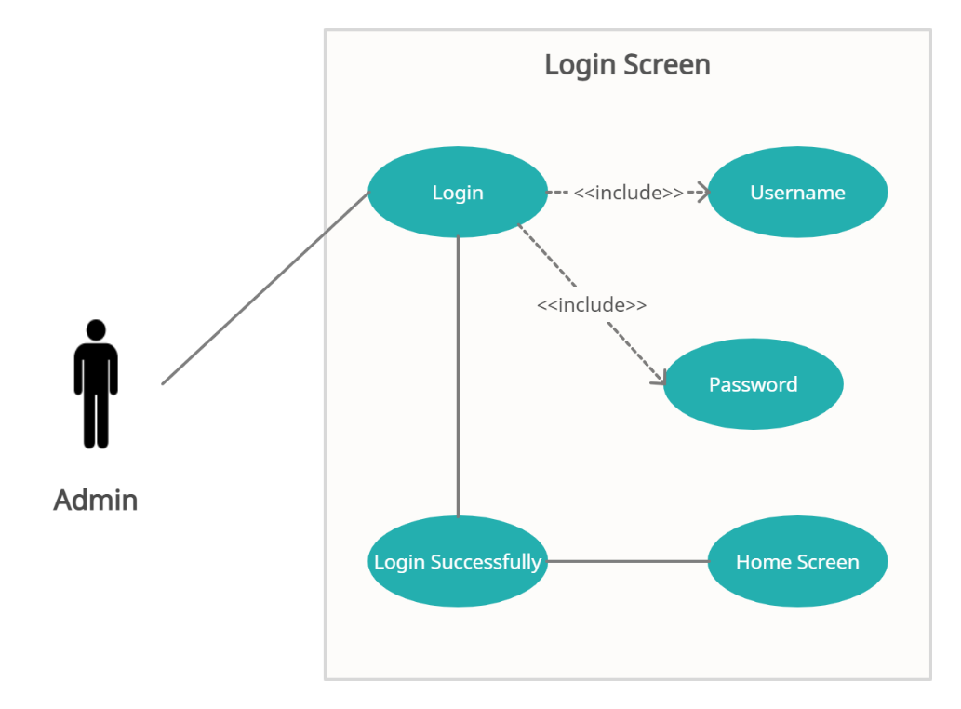

#### Admin Login 4.1

**Use Case Name:**

Admin Login

**Actor:**

Admin

**Summary:**

Admin can login to his account.

**Pre-Condition:**

Login account for Admin, an Admin user must be created before login into account.

**Post-Condition:**

After login, Admin go to home screen.

The admin will perform his respective tasks.

**Expectations:**

The system may show Connection Error.

Not allowing admin to login the account.

(giving the wrong information which not satisfies the authentication principles)

**Assumptions:**

The system will ask the user to enter his/her username and password and all the required fields.

Then will check user into his own account to perform his respective task.

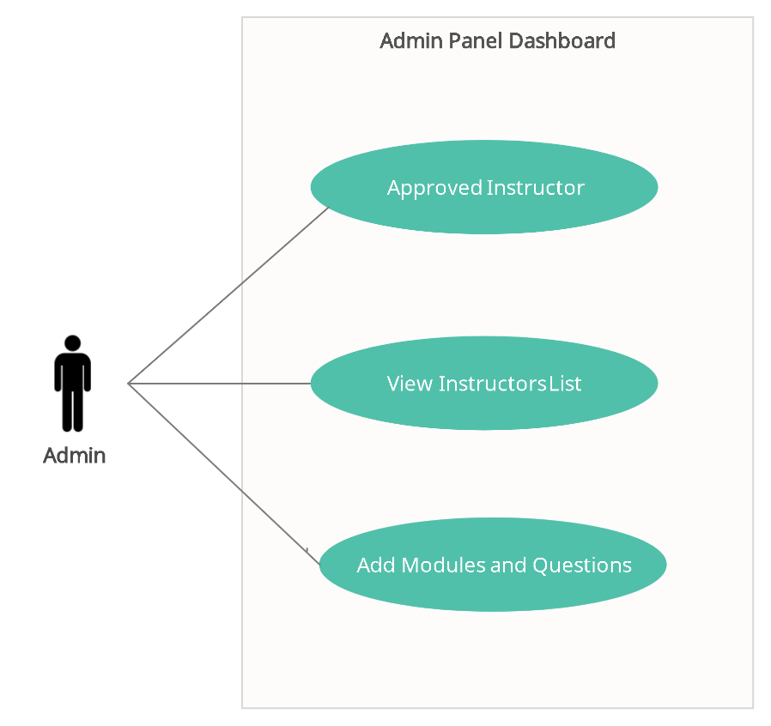

#### Admin Panel Dashboard 4.2

**Use Case Name:**

Approve Instructor or Doctor

**Actor:**

Admin

**Summary:**

Admin should also approve the Instructor or Doctor for login into App.

**Pre-Condition:**

Instructor or Doctor must be sign up for account

**Post-Condition:**

Admin Add Instructor or Doctor Information. Then he/she can login.

**Expectations:**

The system may show Connection Error.

Not allowing admin to create the account.

(Because of the mobile phone number is already in use or giving the wrong information which not satisfies the authentication principles)

**Assumptions:**

The system will ask to add confirm information.

Then the user can login into his own account to perform his respective task.

**Use Case Name:**

Add Modules and Questions

**Actor:**

Admin

**Summary:**

Admin can add Modules and Questions in the modules.

**Pre-Condition:**

He/she must download the application.

**Post-Condition:**

Admin can add Modules and Questions in the modules.

**Expectations:**

The system may show Connection Error.

**Assumptions:**

The system will ask to add Modules and questions in modules.

Then Instructor can instruct the child through the questions.

### **Instructor or Doctor Panel Use Case Scenarios**

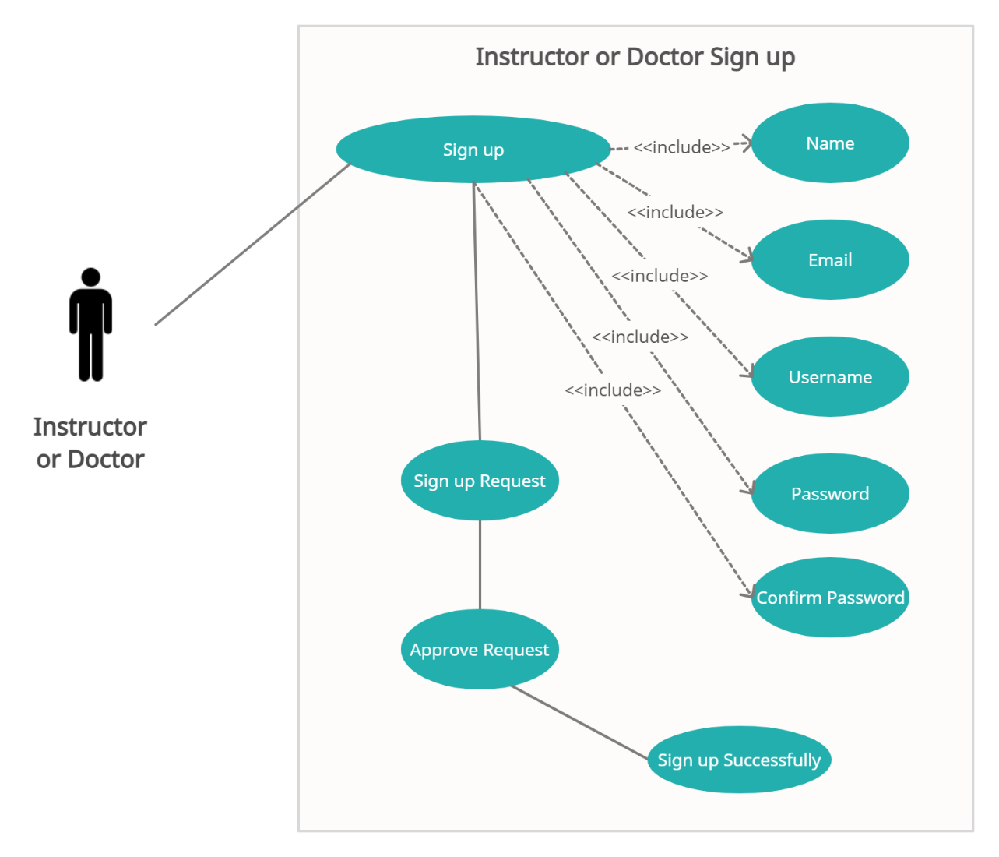

#### Instructor or Doctor Sign up Figure 4.3

**Use Case Name:**

Instructor or Doctor Sign up

**Actor:**

Instructor or Doctor

**Summary:**

Instructor or Doctor can make his/her account.

**Pre-Condition:**

He/she must download the application.

**Post-Condition:**

After Sign Up shows the login screen to the user

**Expectations:**

The system may show Connection Error.

Not allowing users to create the account.

(Because the mobile phone number is already in use or giving the wrong information which not satisfies the authentication principles)

**Assumptions:**

The system will ask the user to enter his/her username and password and all the required fields.

Then user will login into his own account to perform his respective task.

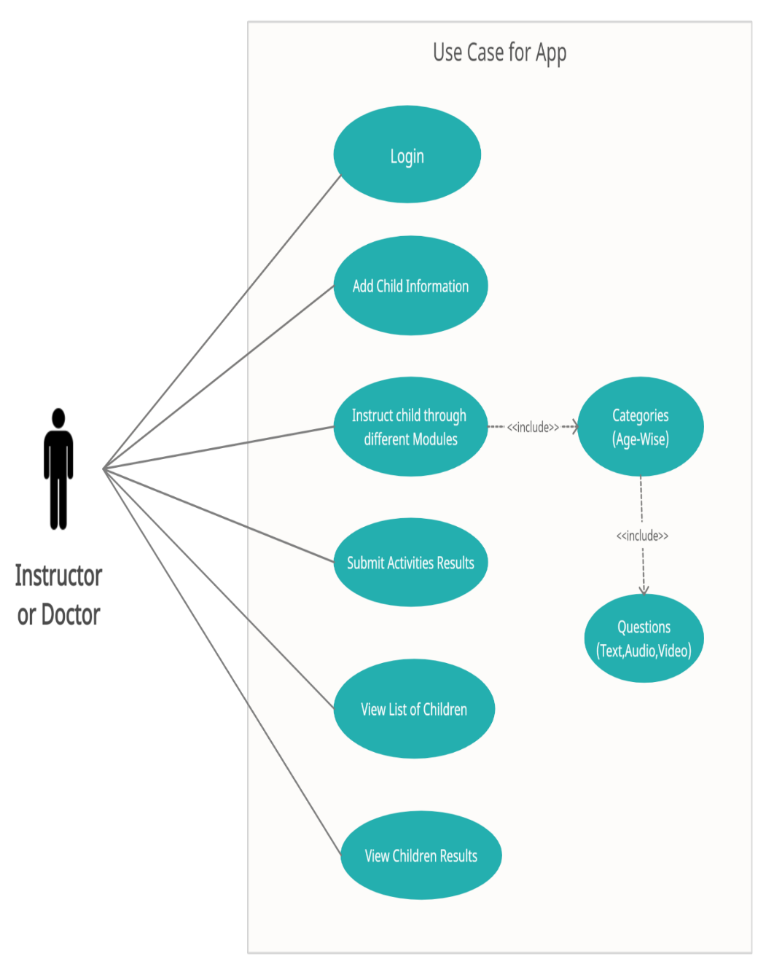

#### Instructor or Doctor Sign up Figure 4.4

**Use Case Name:**

Instructor or Doctor Login

**Actor:**

Instructor or Doctor

**Summary:**

Instructor or Doctor can login to its account.

**Pre-Condition:**

Login account for Instructor or Doctor must be created before login into account.

**Post-Condition:**

After login, the Instructor or Doctor will perform his respective tasks.

**Expectations:**

The system may show Connection Error.

Not allowing users to login the account.

(giving the wrong information which not satisfies the authentication principles)

**Assumptions:**

The system will ask the user to enter his/her username and password and all the required fields.

Then will check user into his own account to perform his respective task.

**Use Case Name:**

Add Disabled Child

**Actor:**

Instructor or Doctor

**Summary:**

Instructor or Doctor should add disabled child information.

**Pre-Condition:**

He/she must login to the application.

**Post-Condition:**

Instructor or Doctor can instruct the child through different scope of modules and age wise-categories questions.

**Expectations:**

The system may show Connection Error.

Not allowing Instructor or Doctor to add information about the child.

(Because giving the wrong information which not satisfies the authentication principles or child information is already added)

**Assumptions:**

The system will ask to add information.

Then the Instructor or Doctor can instruct the child.

**Use Case Name:**

Instruct Disabled Child

**Actor:**

Instructor or Doctor

**Summary:**

Instructor or Doctor should instruct the child by choosing different modules of scope and age-wise categories and questions.

**Pre-Condition:**

Instructor or Doctor should add disabled child information

**Post-Condition:**

Adding the child activity results, instructor or doctor can submit results.

**Expectations:**

The system may show Connection Error.

**Assumptions:**

The system will ask to submit the results.

**Use Case Name:**

Instructor view results of Disabled Children

**Actor:**

Instructor or Doctor

**Summary:**

Instructor or Doctor can view the of results of the disabled children activities and can assess the Intellectual Disability. Also can assess where improvements are done and where improvements are required.

**Pre-Condition:**

Adding the child activity results, instructor or doctor can submit results.

**Post-Condition:**

Asses the Intellectual disability in the disabled child by comparing previous activity results.

**Expectations:**

The system may show Connection Error.

### **System Use Case**

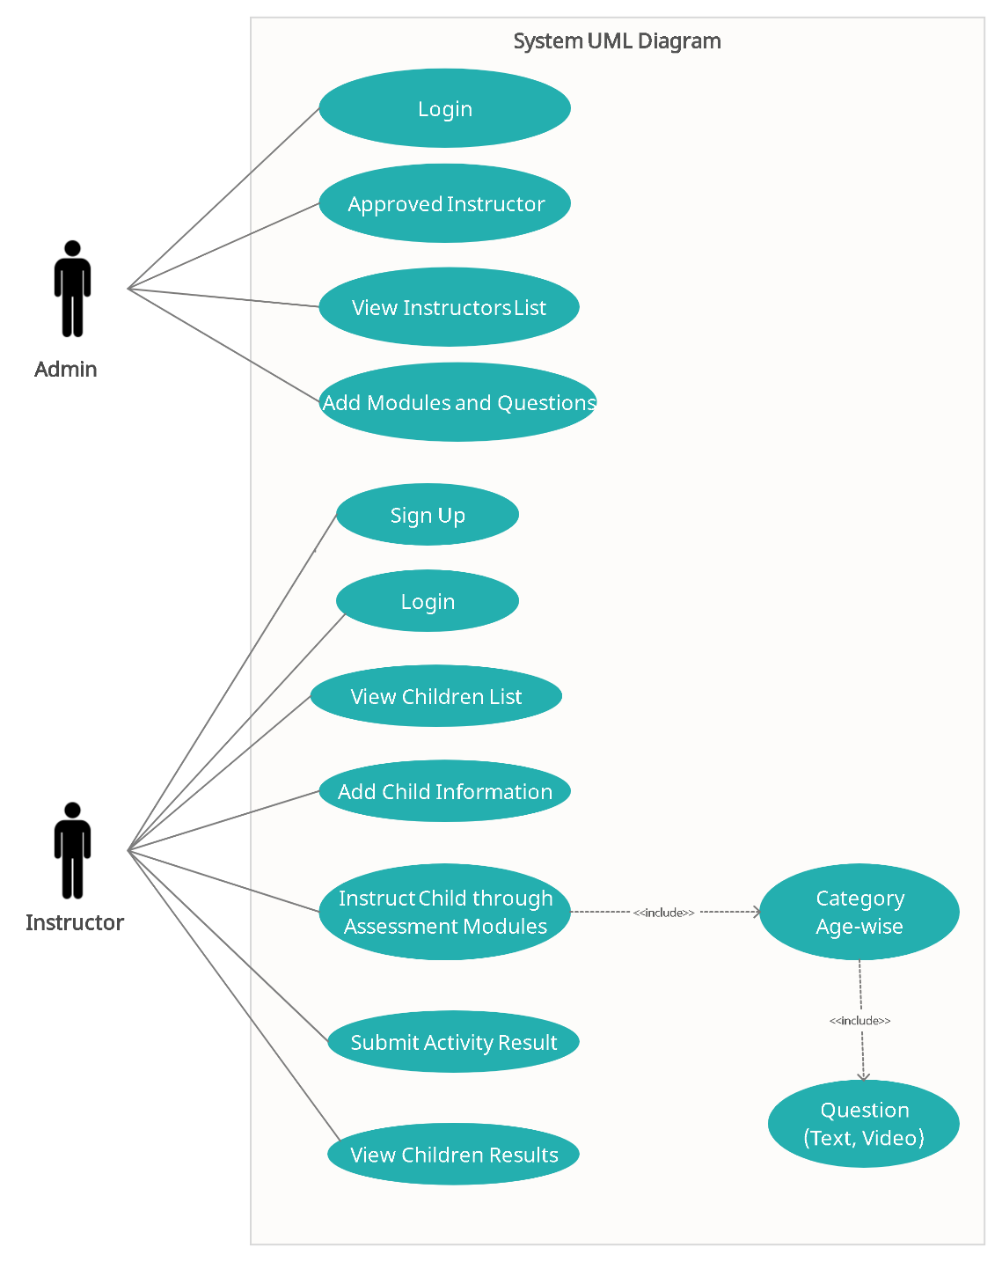

#### Instructor or Doctor Sign up Figure 4.5

### **Service-Oriented Architecture in Cloud Computing**

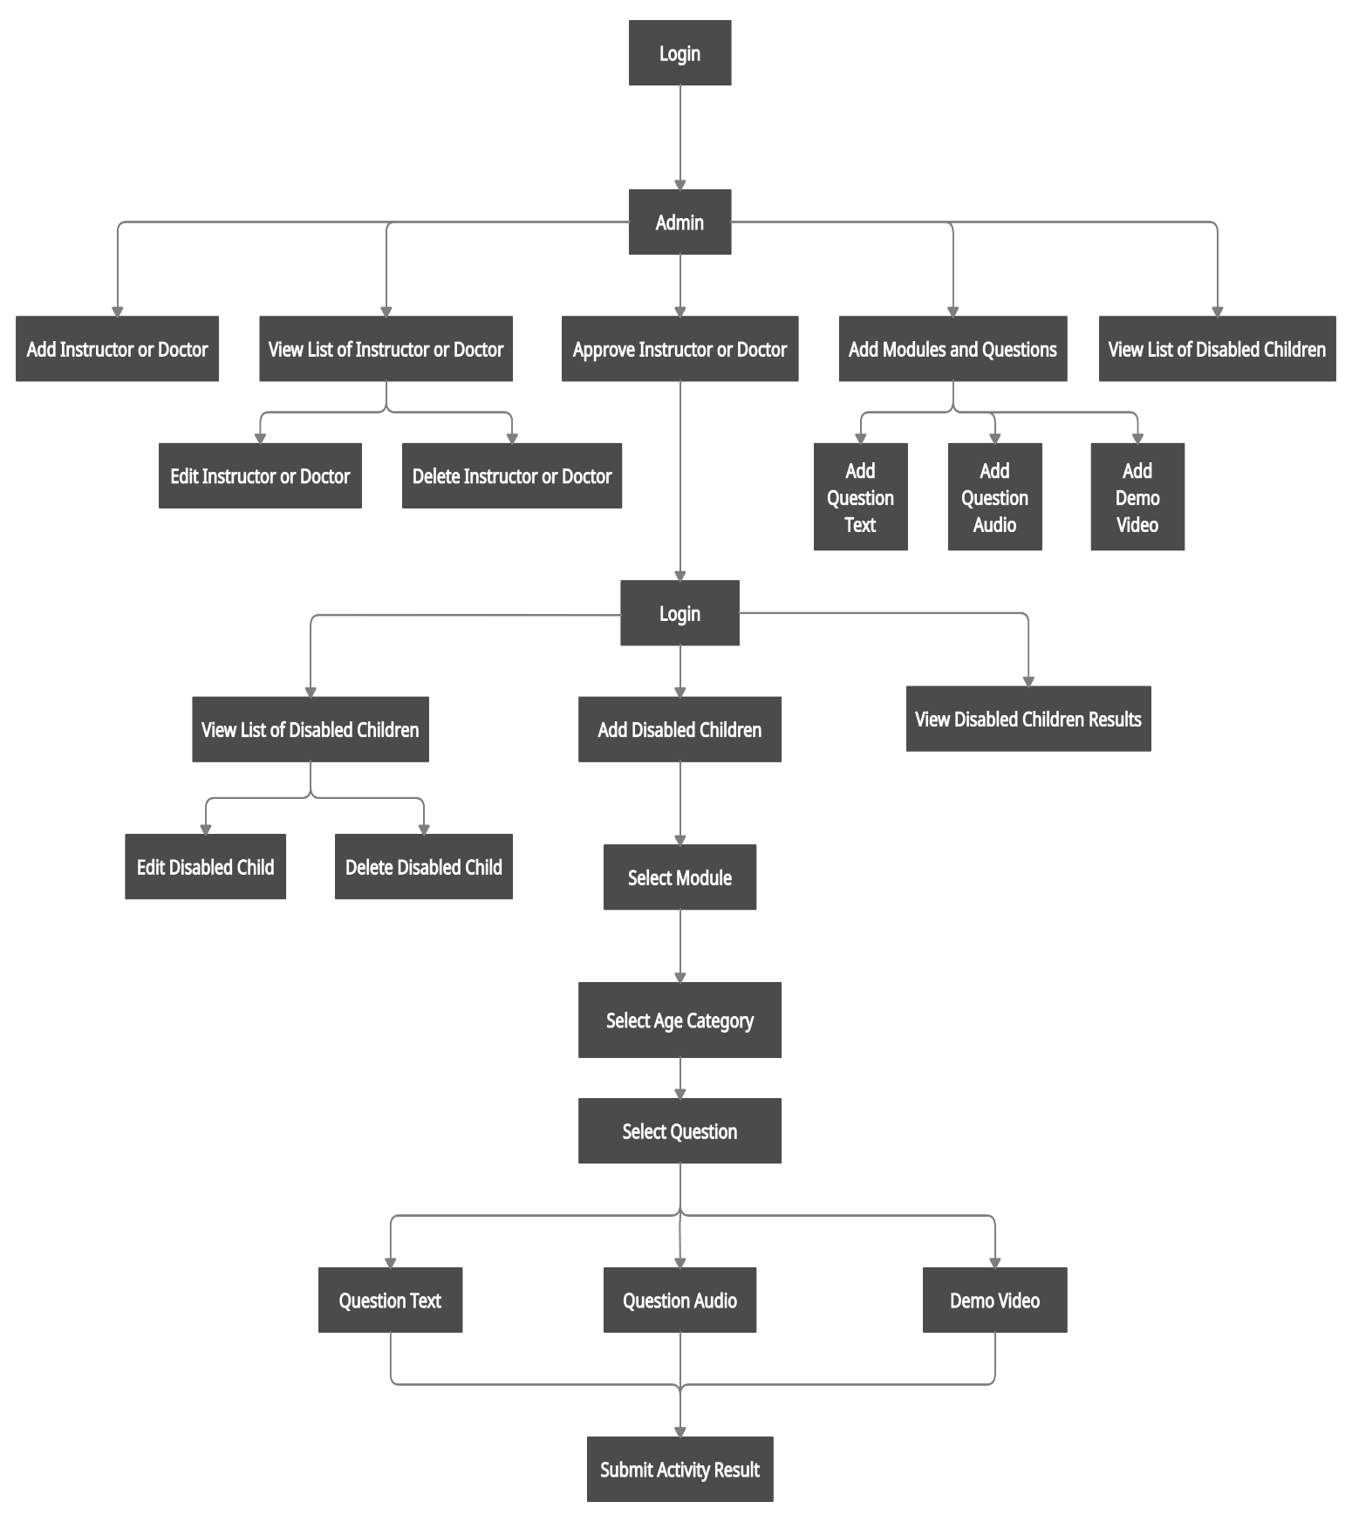

# **System Design**

## **Introduction**

System design is the process or art of defining a system's architecture, components, modules, interfaces, and data to meet the specified requirements. There are overlaps and synergies with the disciplines of systems analysis, systems architecture, and systems engineering. The architectural design for software reveals the overall layout of the system. In this chapter, the system design of Sol Mind systems, dataflow diagrams, and architectural diagrams have been presented.

Section 5.2 Architecture Flow and Pattern defines the architectural flow and URL pattern respectively. Data flow diagrams are explained in Section 5.4 Data Flow Diagrams. UML Diagrams are comprised of Section 5.5 UML Diagrams.

## **Architecture**

Basically, in all the projects architecture of the software defines the workflow and frameworks of the project model. The Architecture also helps the user or the programmers to study the model and easily use the system.

## **System Architecture**

System Architecture shows the workflow of the system that how from the scratch and after following the goals how the target is achieved or how the required functionality is attained by the application or in simple words architecture system shows the behavior and structure of the system. It is the formal description of the project in a very organized way.

## **Sequence Diagrams**

Sequence diagram are one of very important diagrams in the project as the name depicts itself that these diagrams tell the sequence of every events. Diagram includes the messages that passes from one object to other and then other will respond corresponding, every object and actor has an activation time that is it will active for some time and then rest and if need by other object it will active again.

### **Login Sequence Diagram**

Figure 5.3.1 shows that how an Instructor can login into the android app. That app will be of very much guidance for the users in their profile they can view all of their information and also the information about their students which also include the name, age, disability, previous history, results and other stuff all of this stuff is explained in the diagram systematically.

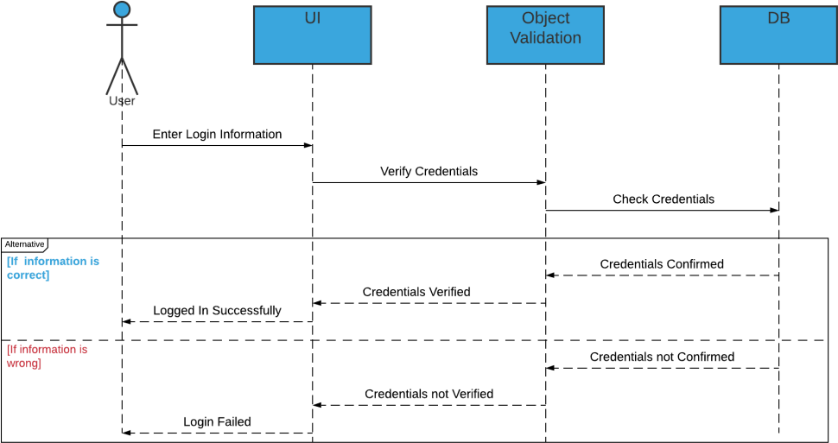

Figure 5.3.1 Login Sequence Diagram

### **View Student List Sequence Diagram**

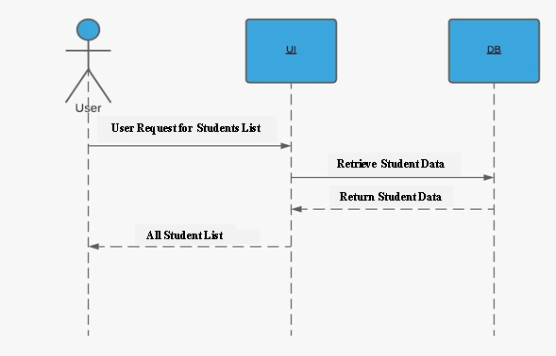

Figure 5.3.2 View Student List Sequence Diagram

### **Student Details Sequence Diagram**

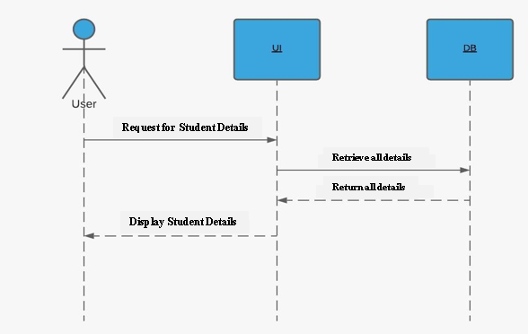

Figure 5.3.3 View Student Details Sequence Diagram

### **Student Test History Sequence Diagram**

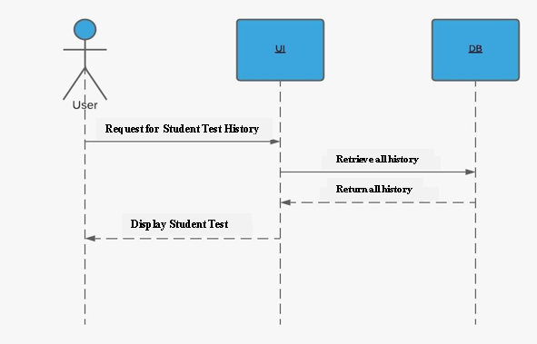

Figure 5.3.4 Student Test History Sequence Diagram

### **Student Assessment Sequence Diagram**

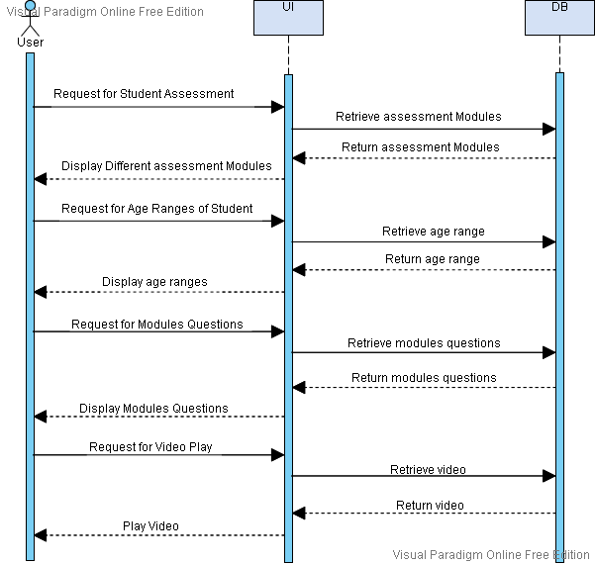

Figure 5.3.4 Student Assessment Sequence Diagram

## **Activity Diagram**

Activity Diagram are also the main part of the architecture diagrams they basically tell the activity of the events how they take place and flow charts of the event occurs. In our Application we have two major actors and one minor actor. The major actors are Admin, Instructor and the minor actors are the disable children.

Below sections show the activity diagrams of both the actors.

### **Admin login Activity Diagram**

This explains the systematically way of reaching the goal after starting from the scratch is this. In this diagram it explains everything from the Admin login to the reaching of the admin panel is all explained in this diagram.

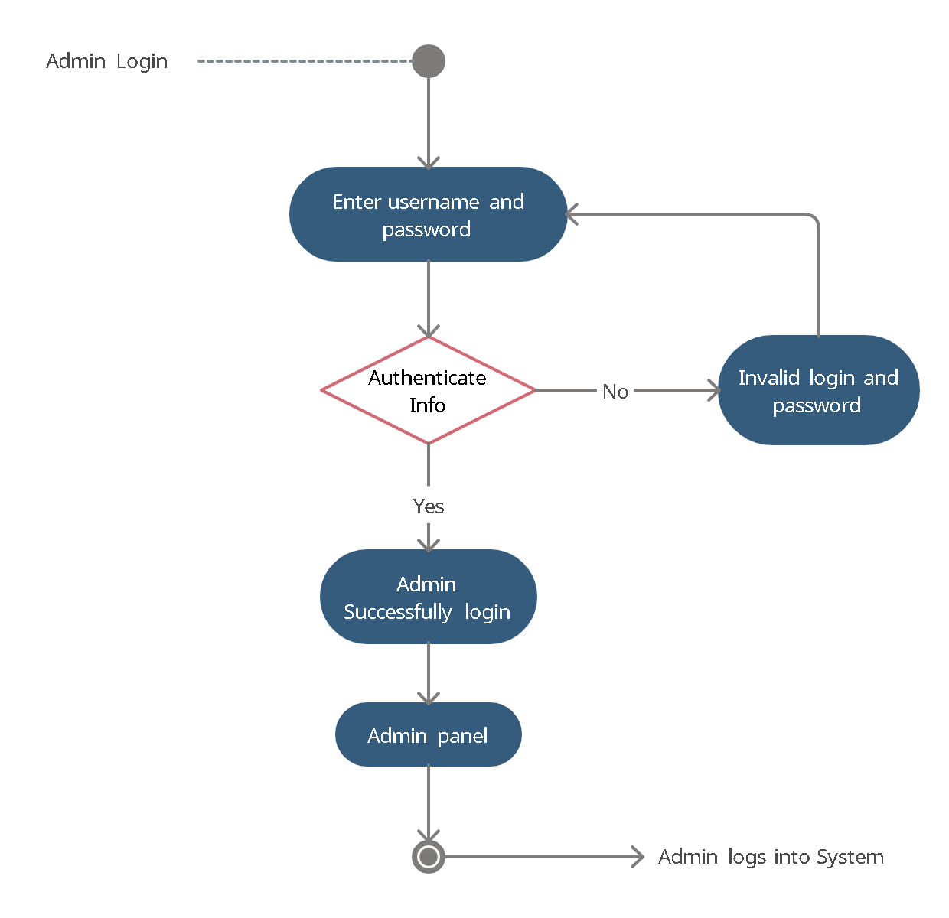

Figure 5.5.1 Admin Login Activity Diagram

### **Admin Panel Activity Diagram**

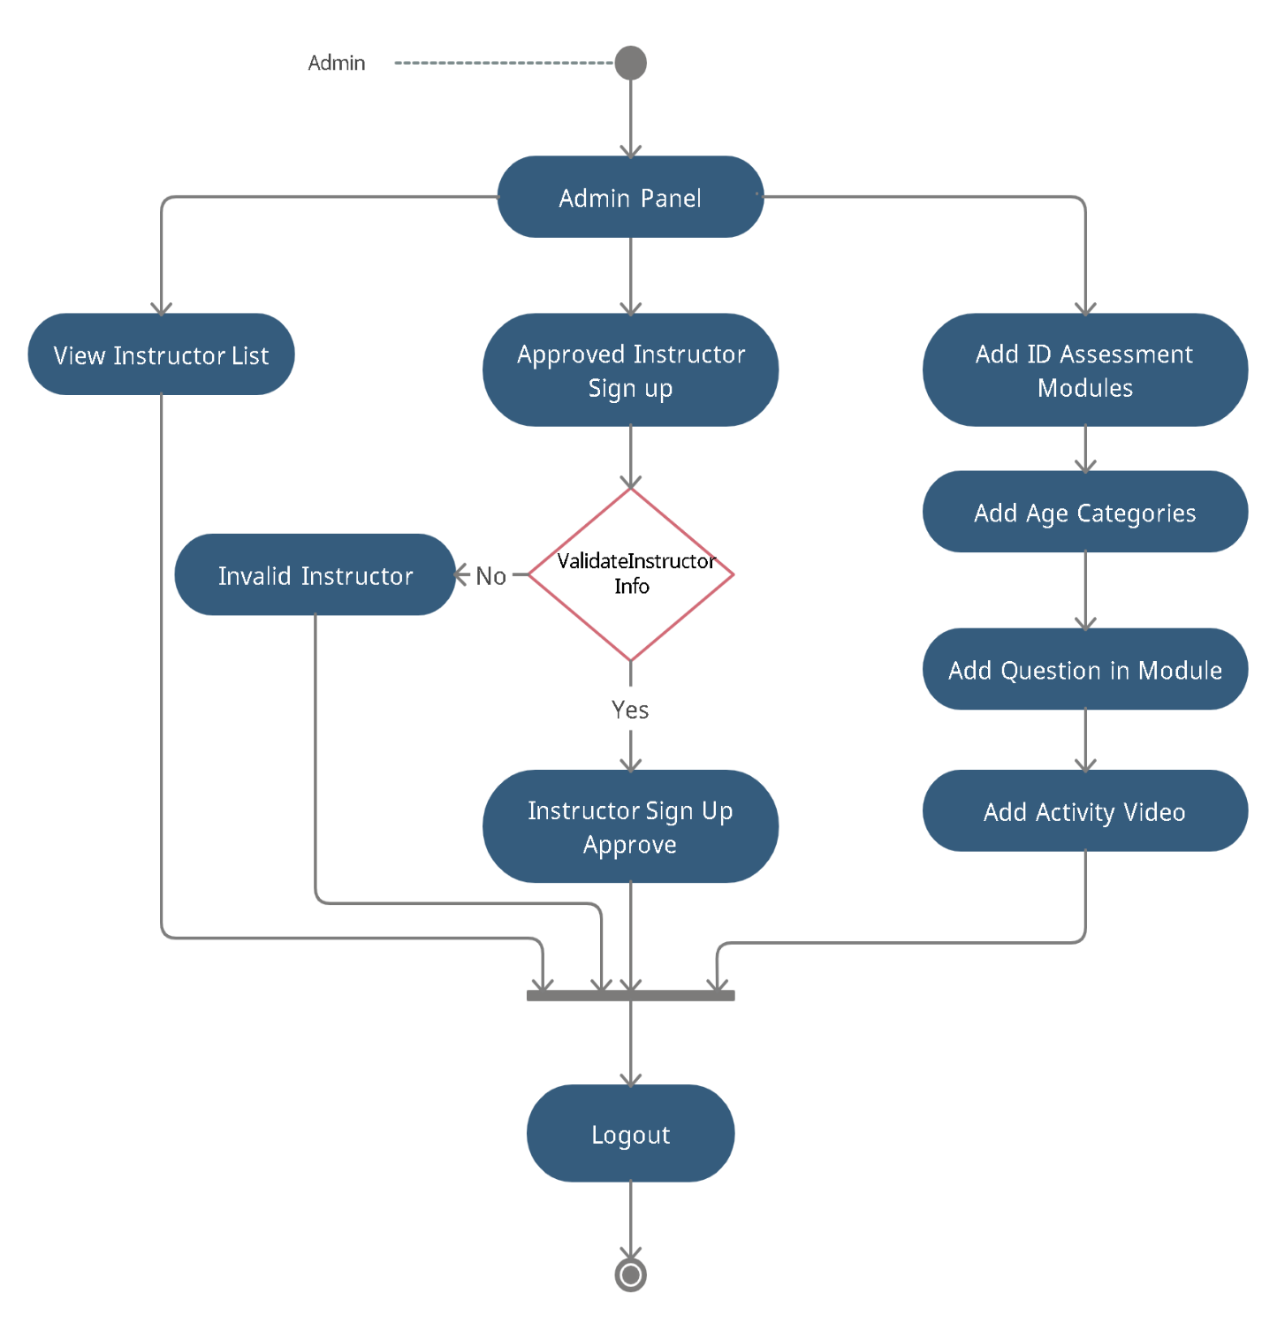

Figure 5.5.2 Admin Panel Activity Diagram

### **Instructor Login Activity Diagram**

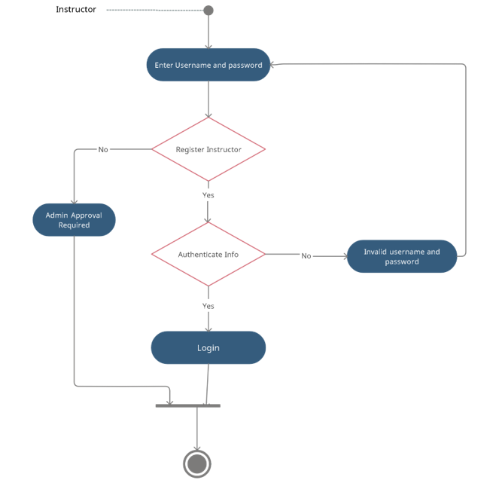

Figure 5.5.3 Instructor Login Activity Diagram

### **Instructor Login Activity Diagram**

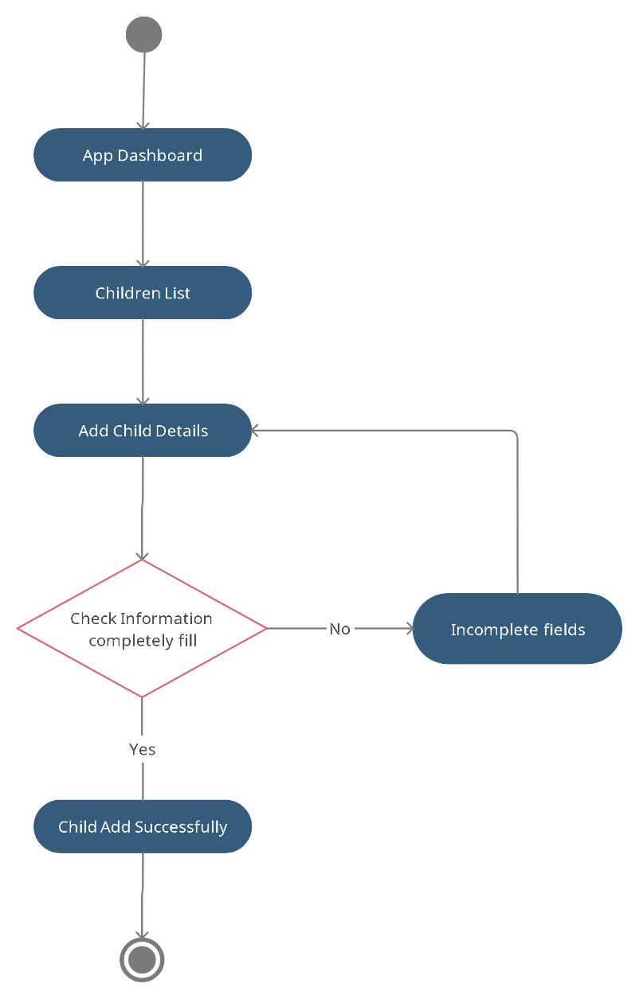

Figure 5.5.4 Instructor Login Activity Diagram

### **Child Assessment Activity Diagram**

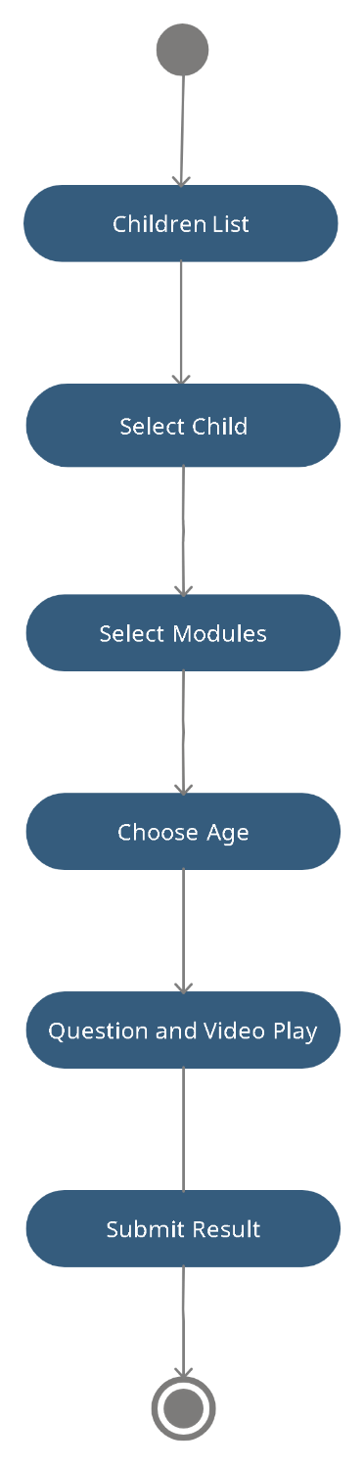

Figure 5.5.5 Instructor Login Activity Diagram

# **Implementation**

## **Overview**

To create and optimize this mobile application so that it works optimally and quickly. JavaScript does most of the work (programming) because it gives users (programmers) a lot of flexibility by offering lots of features and possibilities. It is also considered as one of the most powerful programming languages.

So, following the abilities of the language, we have used the React Native framework

of JavaScript.

## **Basic knowledge about React Native framework**

React Native is a JavaScript framework based on the VSCODE tool and developed by Facebook. It was developed in JavaScript by Facebook. React Native is a bit younger than most of mobile application frameworks, but it holds great promise and is already gaining popularity among mobile app developers.

### **Why React Native?**

React Native is specially designed for easy operation and expansion. The basic idea of React Native is to create a solid foundation for other complex mobile applications. From then you can freely plug-in the required extensions. You can also freely create your modules. React Native is suitable for all kinds of projects. Particularly good for prototyping. React Native is based on many external libraries. It used different libraries to perform the tasks.

If Native and swift is very powerful, the question remains why are we using React Native as our mobile application framework. These are the best java script web frameworks, but among all react native is very impressive:

* Once write your code and use it anywhere.
* User interface & User experience focused
* Programming language
* Strong Community among the world
* Many research has been done & tested a lot.
* Support 3rd party libraries
* NPM
* Mobile Environment Performance

React Native also offers much more control during the development phase of the project. Follow the principles of minimalism and we decide how the application is written.

* React Native is lightweight and modular, so you can easily convert it to the required android app and iOS app with a few extensions.
* Composition
* Common Abstraction
* Escape Hatches
* Stability
* HTTP request processing function
* High flexibility
* Interoperability
* Scheduling
* Developer Experience
* Debugging

The configuration is much more flexible than native app and offers a solution for every production requirement.

In short, react native is one of the most sophisticated and feature-rich framework. React Native offers all the benefits of fast templates, comprehensive unit testing capabilities at the mobile and library application level, and comprehensive documentation.

### **Frontend structure**

Our web application’s frontend is highly user friendly. Our fronted structure is completely based on HTML and CSS.

### **Structure of the database**

The database is at the core of any web or software application. Without the database, you cannot get the application you want. The configuration and optimization of the database play an important role in the application. Proper structuring of the database means good standardization, which reduces unnecessary data and redundancies in the database.

We have used MYSQL as a database handler because it is one of the most powerful databases for database configuration and is widely used. HTML and CSS are used to create the design of this mobile application. It is very easy to implement and offers many functions. JavaScript were used to create some interactions in the web application.

### **How to Sign in or Sign Up**

Our Platform shows two buttons as ‘Sign in’ and ‘Sign Up’.

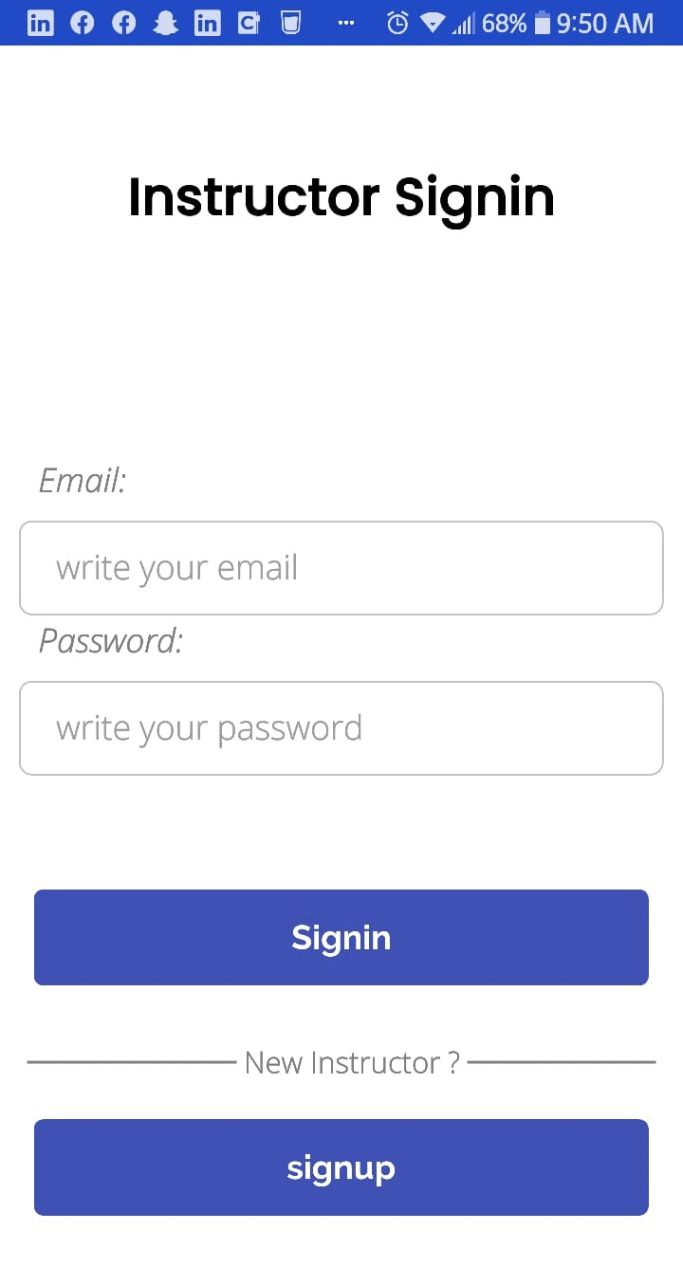

Figure 6.4 Sign in Account

By clicking the Sign Up button, it brings you to the account creation page.

* To open a new account. It requires a unique username.
* Authenticated Email
* Password
* Once you are done with the above details. You are good to log into the account.

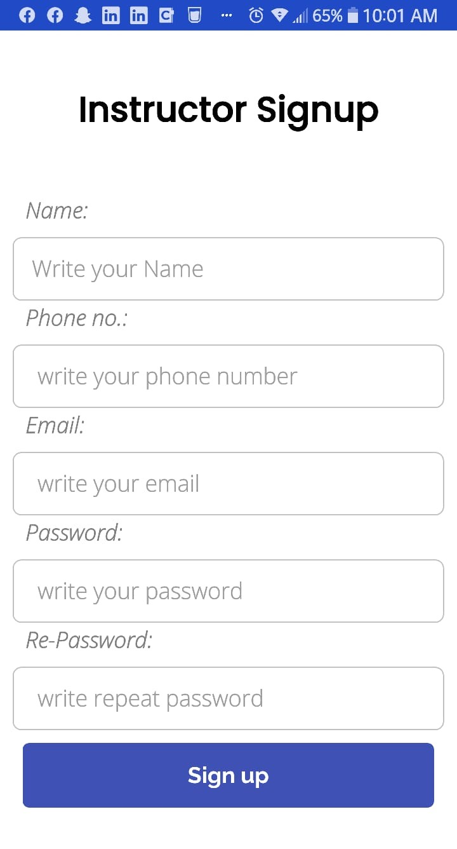

Figure 6.5 Account Creation

**Admin Panel**

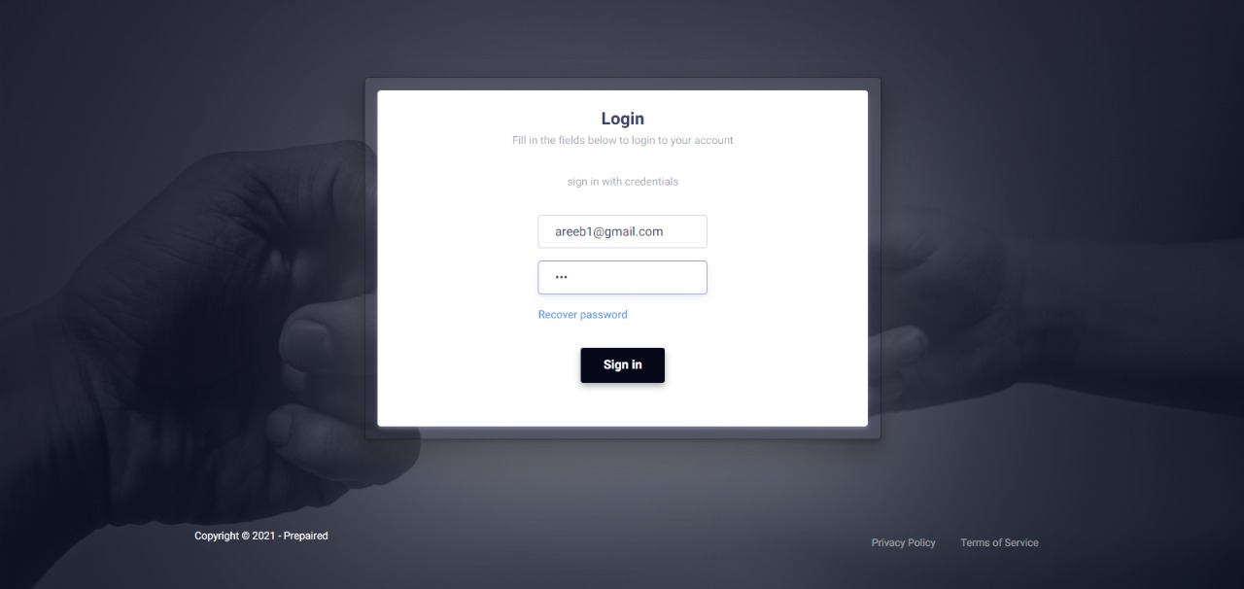

Figure 6.6 Sign In

In admin panel instructor will sign in by writing his email and password.

**Home Screen:**

Main Page will show 3 states

* All Users
* Add age as category
* Add questions

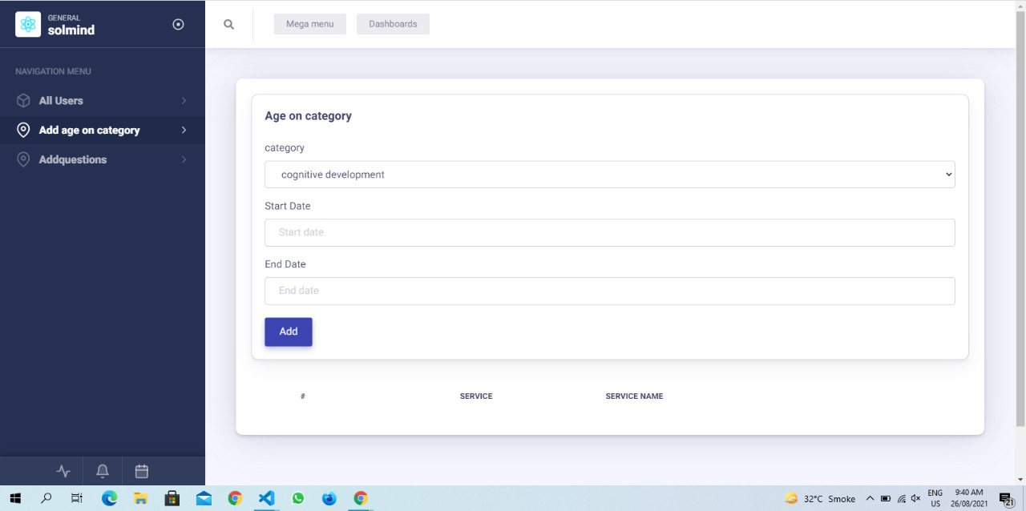

Figure 6.7 Sign Up

**All Users:**

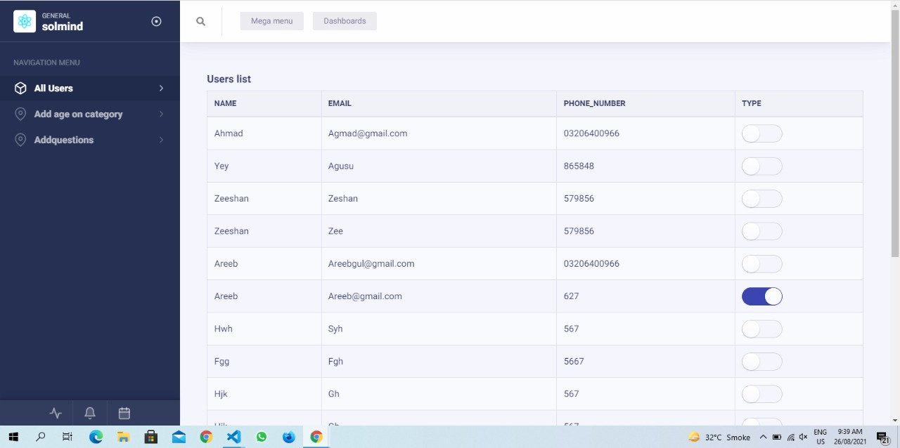

Figure 6.8 All Users

**Add age or category:**



Figure 6.9 Add Age or Category

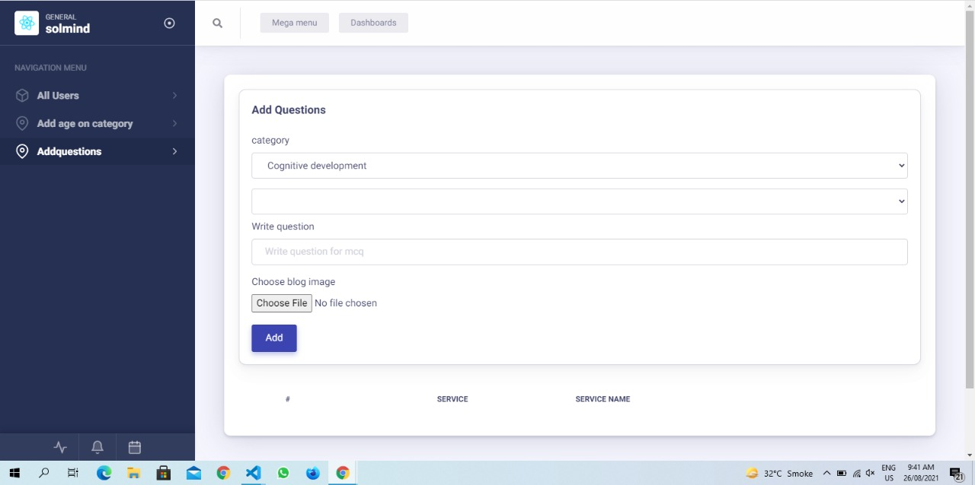

Figure 6.10 Add Questions

### **How sign in works?**

If you have already created your account successfully. You can click the login button. It will require your email that you used to sign up for the account. Also, it requires your password.

Once you enter the correct details, you can log in to the account successfully.

In case if you forget the password. You can click the ‘Lost password’ button. Through which you can easily set your password.



Figure 6.6 Sign in

Once you successfully login to your account. You are directed to the User Dashboard.

**Admin Panel:**

If you have already created your account successfully. You can click the login button. It will require your email that you used to sign up for the account. Also, it requires your password.

Once you enter the correct details, you can log in to the account successfully.



Figure 6.6 Sign in

Once you successfully login to your account. You are directed to the User Dashboard.

### **How does it work?**

After signing into application, student list will appear in front of screen.

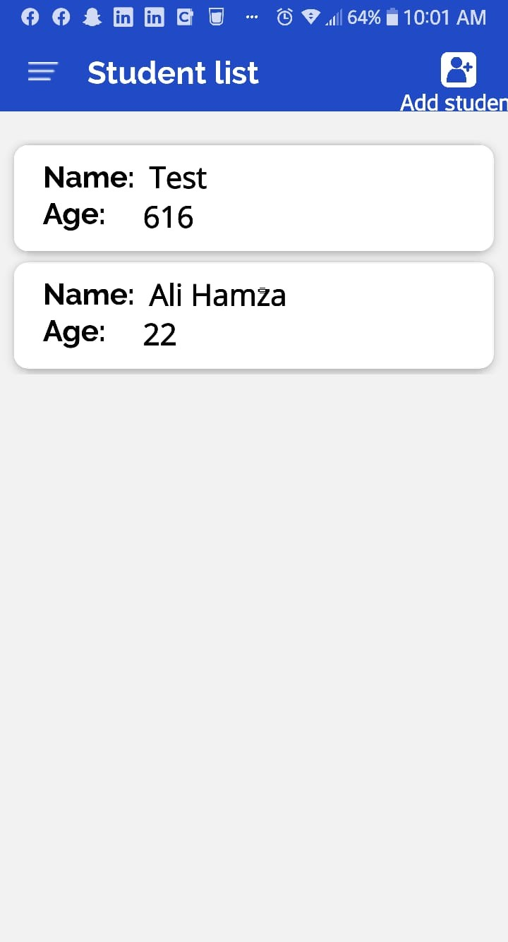

Figure 6.7(a) Student List



Figure 6.7(b) Admin Panel Student List



**Instructor Add Student Details**

Figure 6.8 Add Student

Now, instructor or doctor will add the student as shown at right top of screen.

By clicking on it, Add Student Screen will appear,

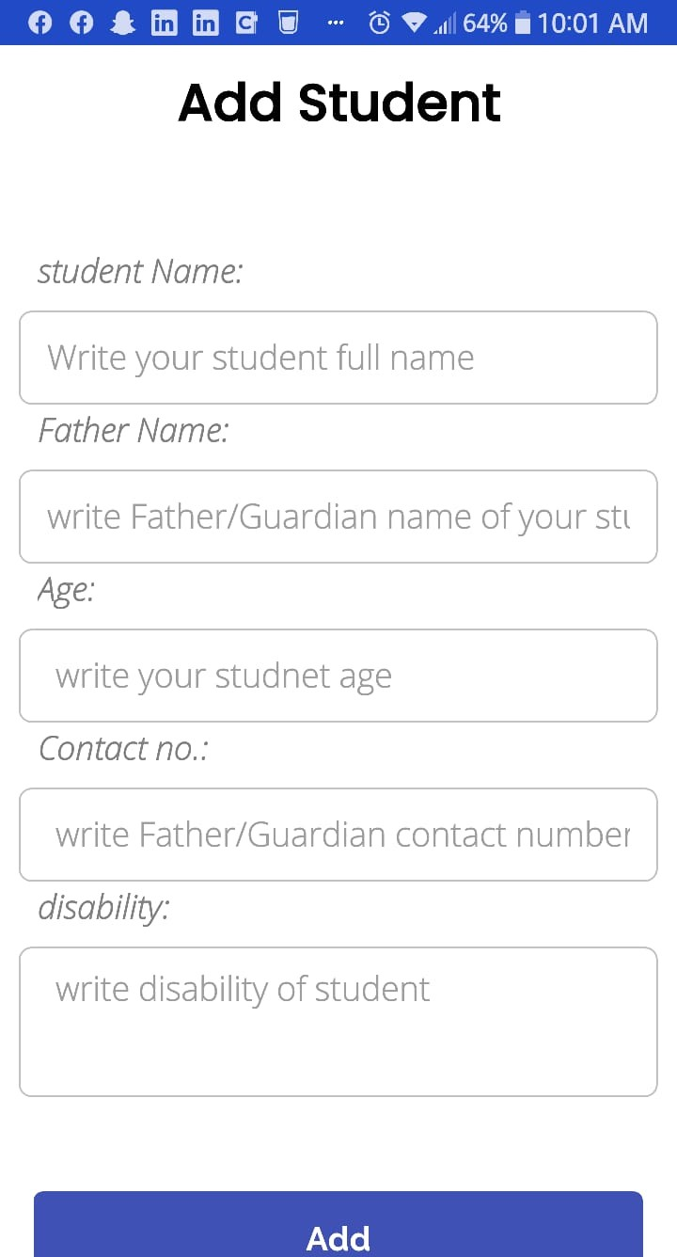

Figure 6.9 Add Student Details

Now, Instructor will add student, by writing their Name, Father Name, Age, Contact No, and their disability.

Then click on ADD, and student will be added into list.

After that, Instructor will select the student by clicking it on the name.

Then Student Details screen will appear on the mobile.

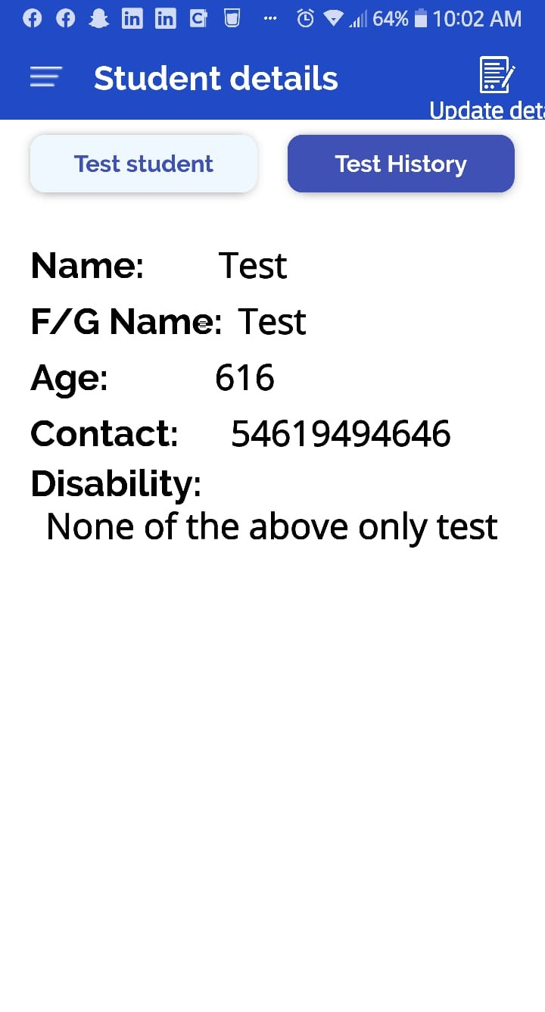

Figure 6.10 Student Details

By clicking on specific student, his details will appear on the screen headed by **STUDENT DETAILS**. In this screen the student’s name, age, disability will be shown. Test Student and Test History are showing at top.

Now, clicking on test student part, select category screen will appear. Testing modules screen will appear. All the four modules will show on screen.

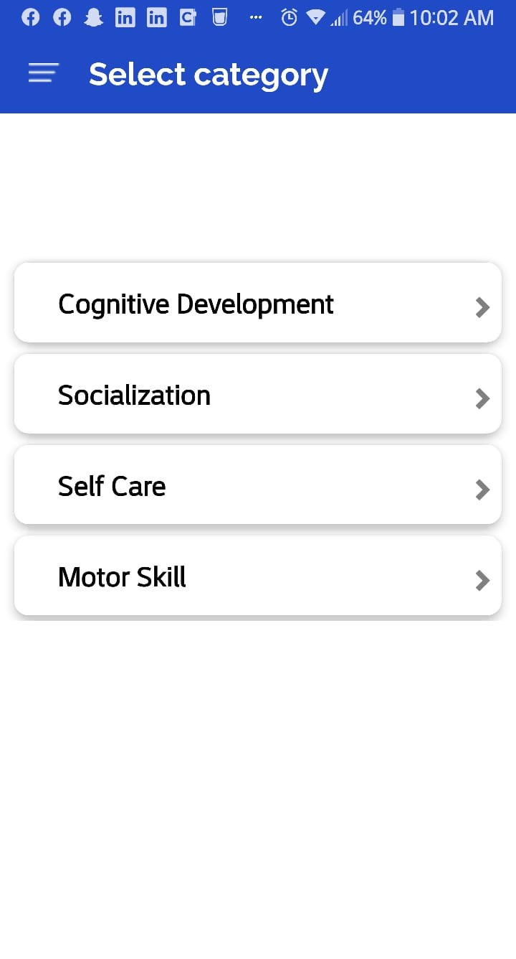

Figure 6.11 Assessment Modules

Now as category screen shown the 4 modules of development and testing for the children, Instructor will select category any of above.

After selecting the module, the select age will appear.

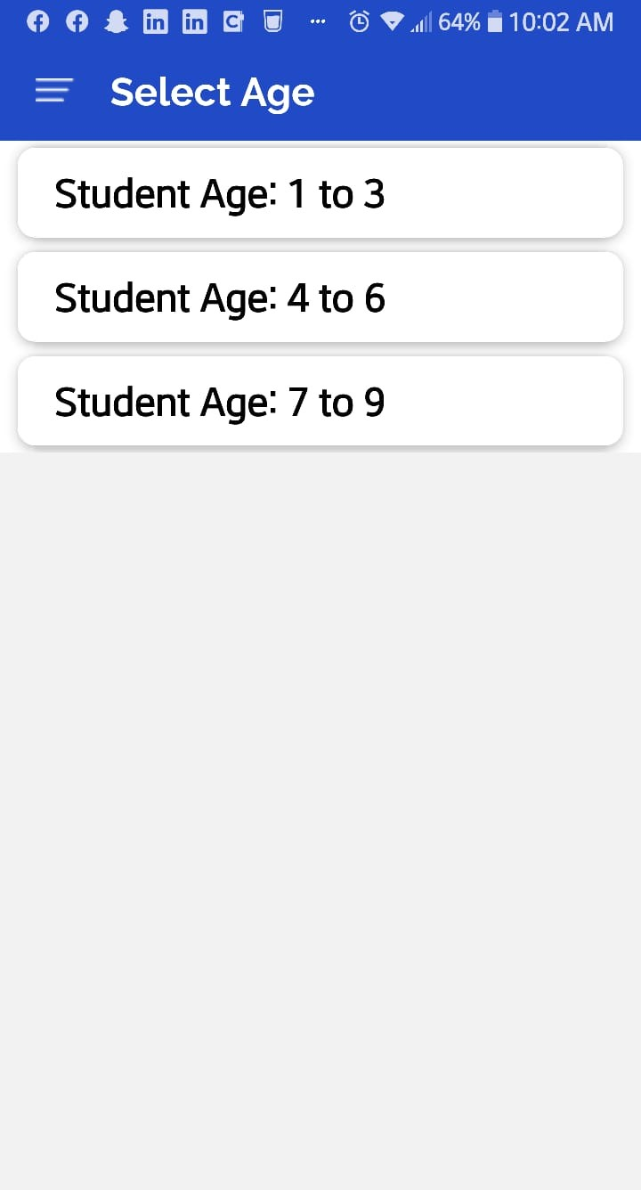

Figure 6.12 Student Age Selection

After that Instructor will select the age of child, for example select 1 to 3. Test screen will appear.

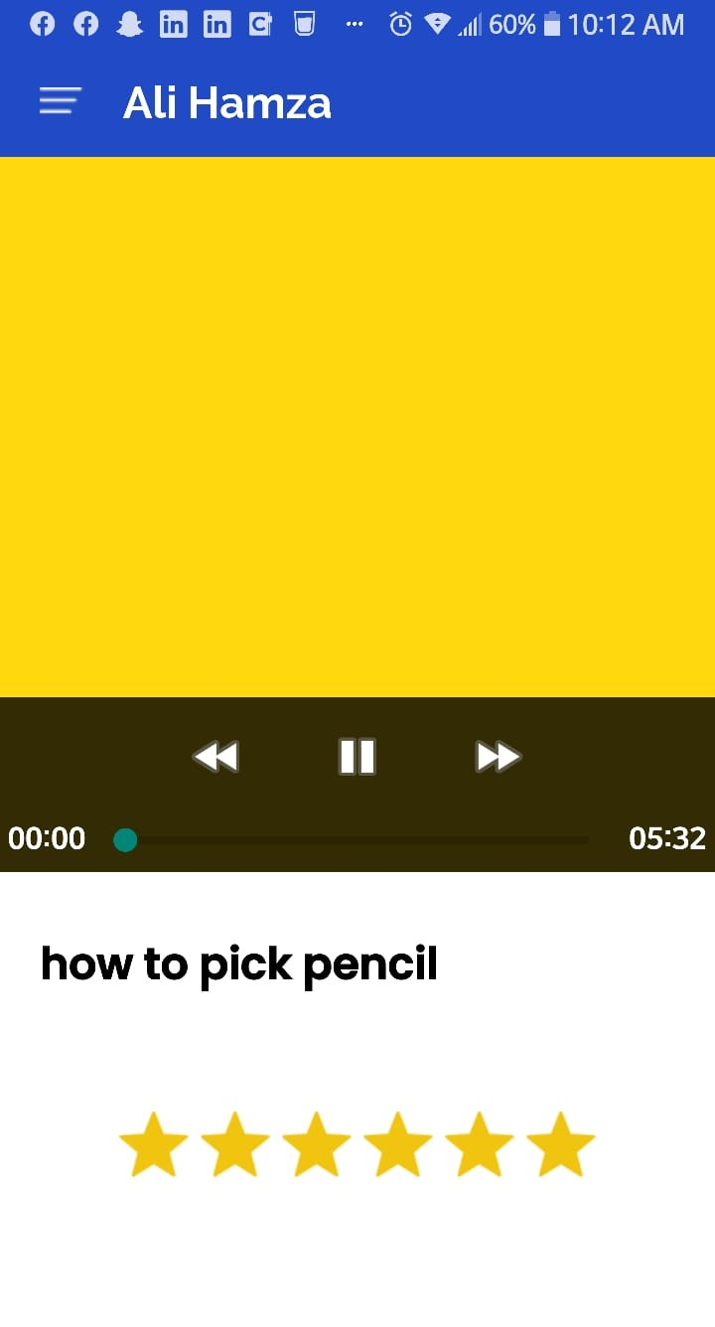

Figure 6.13 Assessment Screen

As we are seeing in the screen the video is appearing, it will educate or tell the story to student to adapt the things are performing in the video.

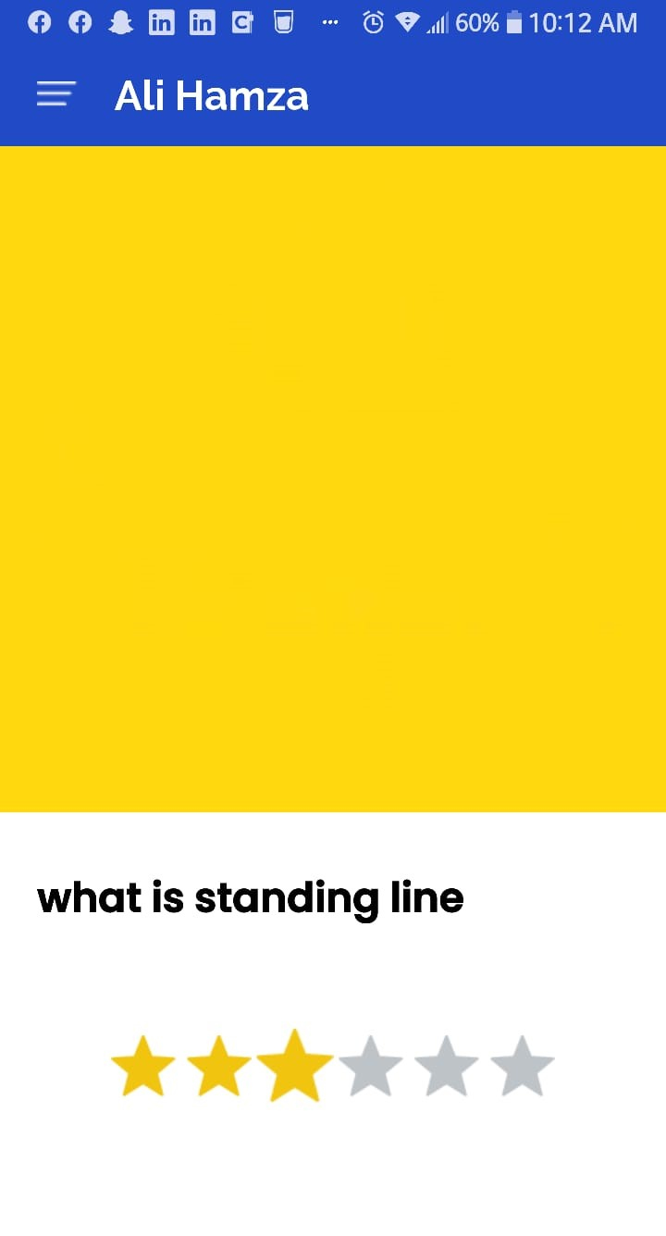

**Instructor Rate the Student**

**Activity**

Figure 6.14 Rate Activity

Instructor will rate the child after assessment and after clicking on the rating again result will appear in next screen.

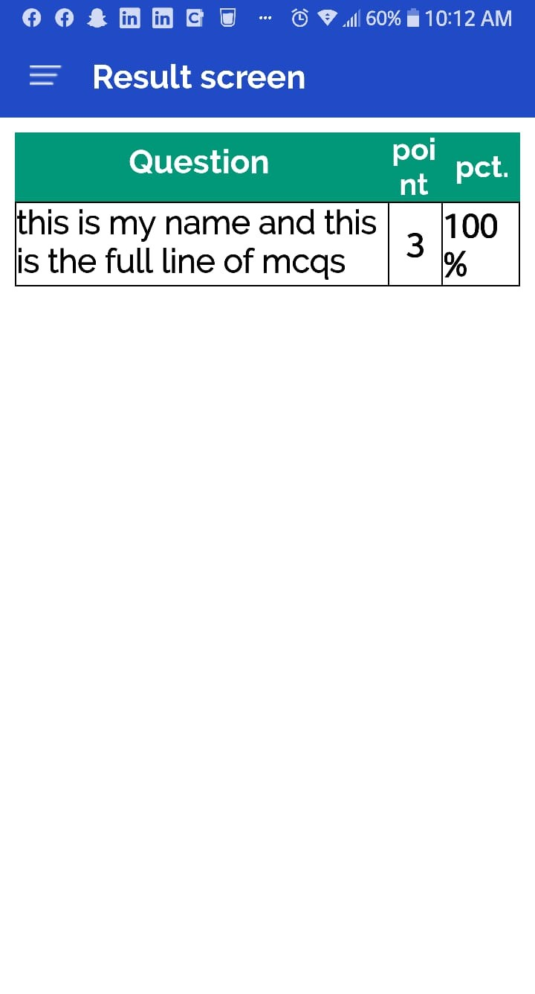

Figure 6.15 Result Screen

Result screen showing the child learning capabilities in percentage. And instructor will give follow prescriptions after the assessment result.

## **Backend Structure**

The backend framework also known as the server-side web framework helps us (developers) to handle all the queries and provide solutions through programming. For our influencer platform, we used Node JS as our framework that deals in the JavaScript programming language.

Moreover, we also used JavaScript with the combination of 3rd party libraries to make the user interaction faster and easier.

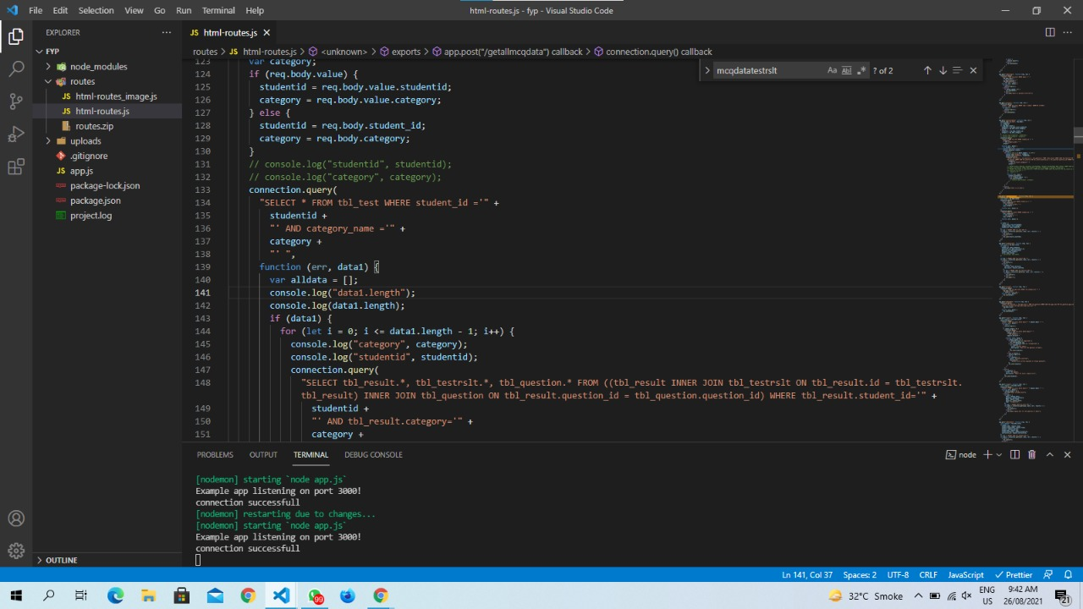

# **System Testing**

* 1. **Test Cases**

These are the conditions under which tester check whether system satisfy functional requirements or not. The tester design the test case from the functional requirements of the system, then apply the test data on these test cases and continue to test until the successful results meet against each requirement.

* 1. **Unit Testing**

Unit Testing is a test level of the software in which individual units/components of the software are tested. The purpose is to verify that each unit of the software executes as designed. A unit is the smallest testable part of any software. It usually has one or a few inputs and usually a single output.

* 1. **User Module Unit Testing**
     1. **Sign Up**

Description: User Account Creation

Pre-Condition: User must enter valid information i.e. unique name etc. Post-Condition: Users can log in using id and password.

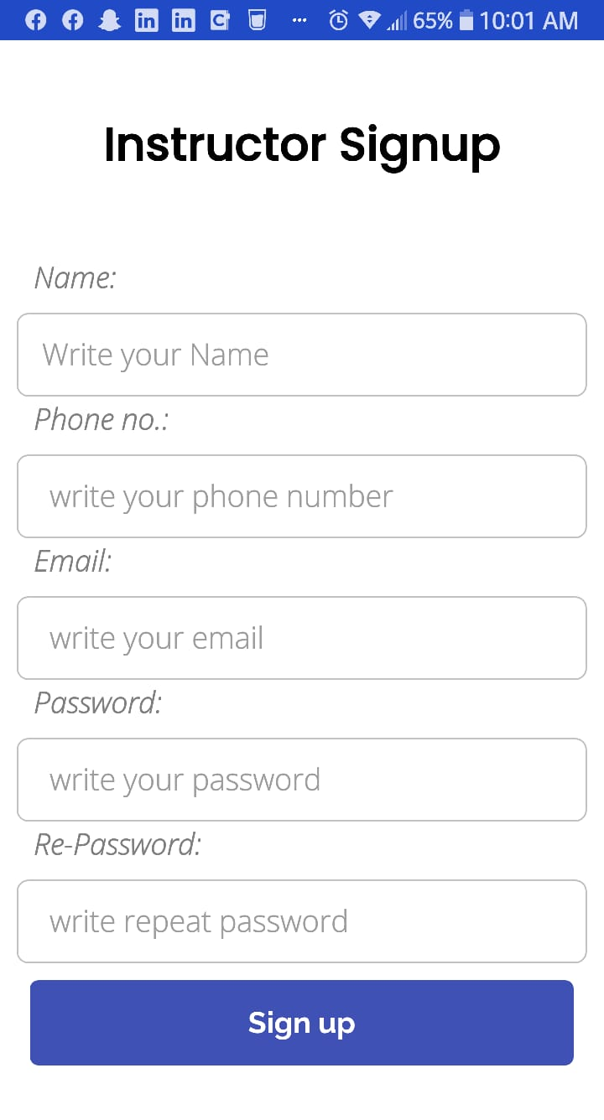

Table 7. 1: Sign Up Test Cases

|  |  |  |  |  |
| --- | --- | --- | --- | --- |
| **Step** | **Test Steps** | **Expected Result** | **Actual Result** | **Pass/Fail** |
| **1** | Open The application | Application homepage | Application Homepage is shown | Pass |
| **2** | Enter the username, email address, and  password | Show error message if the name and email address already exist otherwise  accept the information | An error message is shown | Pass |

|  |  |  |  |  |
| --- | --- | --- | --- | --- |
| **3** | Enter some of the fields leaving other fields blank | Do not enable Register Account Button | Register Account Button is disabled | Pass |
| **4** | Enter information in all fields and then removing some of the information from  fields | Show error message that some fields are missing | An error message is shown | Pass |
| **5** | Enter the password and confirm password | Show error message if passwords do not match otherwise accept the  information | Error Message is shown | Pass |
| **6** | Enter valid information | Information entered on their respective fields and password must be hidden | Information is entered as shown in | Pass |
| **7** | Click on Register  Account button | The system will register  the user | Users will be redirected  to the login page. Fig 7.6 | Pass |
| **8** | Click already to have an account?  Login button | Show Login Screen | Login Screen is shown | Pass |

* + 1. **Log In**

Description: User Authentication

Pre-condition: User should enter valid username and password

Post-condition: User dashboard should be shown after login.

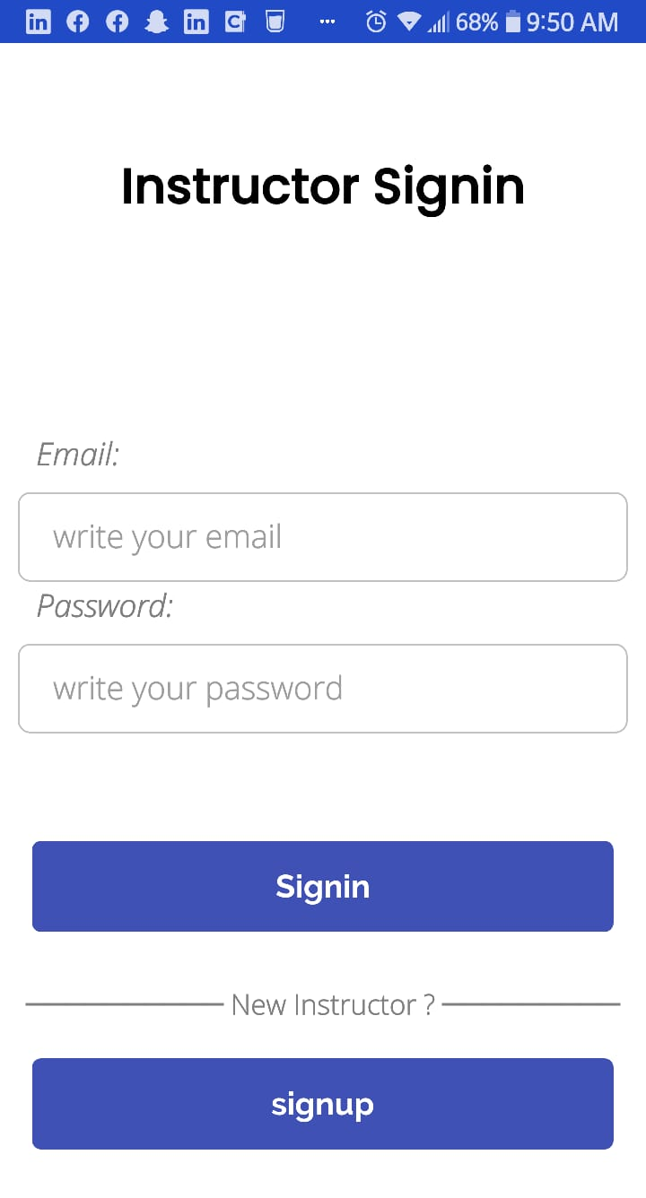



Table 7. 2: Log in Test cases

|  |  |  |  |  |
| --- | --- | --- | --- | --- |
| **Step** | **Test Steps** | **Expected Result** | **Actual Result** | **Pass/Fail** |
| **1** | Open Application | Application homepage | Application webpage is shown | Pass |
| **2** | Enter Username or Password | Show error message that some field is missing | An error message is shown | Pass |
| **3** | Enter invalid  username or password | Show error message that information is incorrect | An error message is shown | Pass |
| **4** | Enter valid username and password | Usernames and passwords are entered in their respective fields. Password  characters are hidden | Information entered correctly as shown in | Pass |
| **5** | Click/Enter Login button | The user must log in and the main interface should open | User logged in successfully and User dashboard is shown | Pass |
| **6** | Click create an account button | Show create an account web page | Create an account web page is shown | Pass |

**7.3.3 Instructor Dashboard**

Description: User dashboard page features

Pre-condition: User have options to edit profile, add/delete/edit influencer.

Post-condition: User must select one of the above-mentioned procedures to use the dashboard.



Table 7. 3: User Home Test cases

|  |  |  |  |  |
| --- | --- | --- | --- | --- |
| **Step** | **Test Steps** | **Expected Result** | **Actual Result** | **Pass/Fail** |
| **1** | Click All Users Button | It will show the all the user are registered | Data was collected from the user to add influencer. | Pass |
| **2** | Click Add age or category | Instructor will add the age and category | Data for the requested user will be added | Pass |
| **3** | Click Add Questions | Questions will be added in to Application | Modules will be added. | Pass |

* 1. **Analysis Module Unit Testing**

**7.5.1 User Analysis**

Description: Analyzing Twitter user

Pre-condition: Anyone with internet access can analyze a user. Post-condition: Users should be able to access the analysis page.

Table 7. 7: User Analysis Module

|  |  |  |  |  |
| --- | --- | --- | --- | --- |
| **Step** | **Test Steps** | **Expected Result** | **Actual Result** | **Pass/Fail** |
| **1** | Launching  Application | Should access  Login Page | Login Page will be opened. | Pass |
| **2** | Entering Email | Email will be entered | Email will show | Pass |
| **3** | Entering Invalid username | The page should return message no user found | No user found the message was shown. | Pass |
| **4** | Entering correct data | The application should return home page with  login | Complete the signing in process | Pass |

**7.5.2 Influencer Finding**

Description: Finding Influencers from twitter user

Pre-condition: Anyone with internet access can analyze a user. Post-condition: Users should be able to access the analysis page.

Table 7. 8: Influencer Finder Module

|  |  |  |  |  |
| --- | --- | --- | --- | --- |
| **Step** | **Test Steps** | **Expected Result** | **Actual Result** | **Pass/Fail** |
| **1** | Launching  Application | Should access  homepage/search page | Search page was opened  *(Figure 7.25)* | Pass |
| **2** | Leaving Field Blank | The system should return an error | An error was shown, asking to input a term.  *(Figure 7.26)* | Pass |
| **3** | Entering Search Term | Analysis page with top 10 influencers should be  returned | The analysis page with top influencers was  shown. *(Figure 7.26)* | Pass |

* 1. **Admin Module Unit Testing**

**7.6.1 Log In**

Description: Admin authentication

Pre-condition: Admin should enter valid username and password Post-condition: The main interface should be shown after login

Table 7. 9: Log in Test cases

|  |  |  |  |  |
| --- | --- | --- | --- | --- |
| **Step** | **Test Steps** | **Expected Result** | **Actual Result** | **Pass/Fail** |
| **1** | Enter/Launch URL | Show login web page | Login webpage is shown | Pass |
| **2** | Enter Username or Password | Show error message that some field is missing | The error message is shown | Pass |
| **3** | Enter invalid username or password | Show error message that information is incorrect | The error message is shown | Pass |
| **4** | Enter valid username and password | Usernames and passwords are entered in their respective fields. Password  characters are hidden | Information entered correctly | Pass |
| **5** | Click/Enter Login button | Admin login and main interface should open | Admin logged in successfully. | Pass |

**7.6.2 Admin Home**

Description: Home page features

Pre-condition: Admin has options to add/delete/edit all users and influencers

Post-condition: Admin must be able to edit/add/delete users & influencers and database should be updated

Table 7. 10: Admin Home Test cases

|  |  |  |  |  |
| --- | --- | --- | --- | --- |
| **Step** | **Test Steps** | **Expected Result** | **Actual Result** | **Pass/Fail** |
| **1** | Dashboard will appear | All Users, Add age or category, Add questions will be shown | Dashboard will appeared | Pass |
| **2** | Click and Add anything | Instructor will perform task | All Users, Category, Questions will show on left side and instructor will perform through it | Pass |

# **Conclusion and Future Work**

## **Conclusion**

Intellectual Disability is a serious issue in the children. The children suffer from ID has serious effects on the mental abilities. ID effects the Intellectual functioning (like cognitive, learning judgement etc.) and adaptive functioning (daily life activities). According to Google searches approximately 2 percent of all the children have an ID. According to a survey about ID effected children in Pakistan most of 70 percent children are living in villages/rural areas. This overlook opportunity for primary treatment causes enormous distress for parents, who rarely obtain accurate information regarding the course, diagnosis, and appropriate possible solutions. There is a need to develop community-level interventions that are practicable, cost-effective, and can be integrated into current healthcare systems.

Inadequate or inaccurate assessment can lead to inappropriate decision making and placement. For example, people may be wrongfully regarded as mentally retarded when in fact their difficulties are mainly due to a hearing or communication or physical impairment. Children who make only limited progress in school may be regarded as mentally retarded without proper assessment of their intellectual functioning. In many societies, resources will then be denied to these individuals on the grounds that their mental retardation makes it unlikely that they will be able to benefit from them, thus further reducing their opportunities to learn. This is double discrimination, first on the grounds of faulty assessment and again because the ability of people with mental retardation has been underestimated. It is axiomatic, therefore, that tests should always be used positively, to meet the needs of individuals or groups.

Our qualitative and quantitative data from this mixed-methods study of intellectual disabilities in a resource-poor context reveals that: a) discovery is delayed due to a lack of an advanced strategy of routine child health checkups.

b) There is a large time delay between the discovery of developmental disorders and the presentation of those problems to a health care professional.

c) Lack of knowledge of new approaches that are likely to improve outcomes is a major impediment to therapy.

d) Physical constraint and strong family monitoring are the mainstays of home management.

e) Intellectual disabilities are humiliated, resulting in less opportunities for these children and families to participate in community events and high levels of stress among caregivers.

f) Health-care professional interviews reveal a lack of recognition and understanding of fundamental management of such diseases at the primary-care level.

Conclusion Intellectual impairments are generally complex, and they differ from other types of mental illness that do not have a specific treatment. This is a challenge for the disabled to survive throughout time, and the disabled are often ignorant of their situations and health problems. These limitations appear in a variety of ways and are caused by a variety of factors. It varies not only across time, but also across societies. The problems result mostly from the daily hardships of living with a diagnosed handicap, which are exacerbated by social stigma and cruelty. Uncertainty about the issue leads to unfavorable social perceptions, which have an impact on both people with disabilities and their families. Initially, intellectual disabilities were known by a variety of names, but several cases have since been generalized, and research in the field continues. The name of many other significant illnesses was influenced by social conventions of different eras. The humanity of these persons was supposed to be overwhelmed by this disability due to the social irrational concept. They are sometimes referred to as "intellectual retards", which considers them as things instead of people, and is an insult to their personalities. It's really terrible to be termed such things, irrespective of a person's medical condition, and it has haunted many generations of families to cure their crippled family member because it would bring with it a social stigma that would ruin their status in this ostensibly informed and logical society.

## **Future Work**

Our app is built in react native and NodeJS, using MySQL as database. It’s easy to understand and maintain. In future, we are going to add remaining modules, like Verbal communication, non-verbal communication etc. In future, we have plan to add machine learning and its algorithm to concise the assessment of children. It’s going to be helpful for the children and instructors on learning and assessment process. Basically, our target to achieve is globalize the issue and its solution by implementing the digital form of assessment. In future, the application will used different sets of learning platforms, for the learning of the children. As the research is going on for the children intellectual disabilities, the application will follow the rules as per instructions.

# 

**References**

* 1. The first indication of an intellectual disability (ID, formerly mental retardation) <https://www.gulfbend.org/poc/view_doc.php?type=doc&id=10345&cn=208>
  2. Family Support Services: Roughly 75% of persons with intellectual disabilities reside with family members.

<https://www.gulfbend.org/poc/view_doc.php?type=doc&id=10376&cn=208>

* 1. There are literally hundreds of psychological tests in existence. <https://www.gulfbend.org/poc/view_doc.php?type=doc&id=1211&cn=18>
  2. The purpose of eliciting the history is to establish that there is an evidence <https://www.ncbi.nlm.nih.gov/pmc/articles/PMC6345136/>